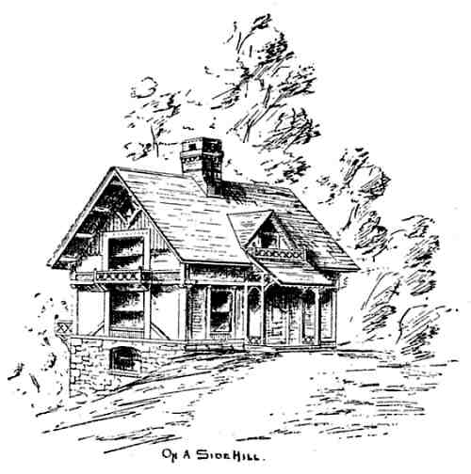

Build Your Dream House

Illustrated.

PREFACE.
These letters between the architect and his friends are composed of hints and
suggestions relating to the building of homes. Their aim is to give practical information to
those about to build, and to strengthen the growing demand for better and truer work.
Even those who are not yet ready to build for themselves are seldom without an
instinctive longing to do so at some future time, and a lively concern in the present
achievements of their friends and neighbors, in this direction. Such will, I trust, find
something interesting and instructive in these pages, and be moved thereby to a more
cordial hatred of whatever is false and useless, and love for the simple and true.

CONTENTS.
LIST OF ILLUSTRATIONS.

PREFACE.

LETTER I.
EVERY MAN SHOULD HAVE A HOME
LETTER II.
A GRATEFUL CLIENT
LETTER III.
THE BEAUTY OF TRUTH AND UTILITY
LETTER IV.
PROFESSIONAL FOLLY

LETTER V.
BUILDING-SITES AND FOUNDATION-WALLS
LETTER VI.
GRAVEL-BANKS AND QUAGMIRES
LETTER VII.
NATURE'S BRICKS ARE BETTER THAN OURS
LETTER VIII.
THERE IS A SOFT SIDE EVEN TO A STONE WALL
LETTER IX.
A BROAD HOUSE IS BETTER THAN A HIGH ONE
LETTER X.
TROUT BROOKS ARE BETTER THAN STREET SEWERS
LETTER XI.
THE STRENGTH AND DURABILITY OF BRICK
LETTER XII.
THE WEAKNESS AND SHAM OF BRICKWORK
LETTER XIII.
SKILL DIGNIFIES THE MOST HUMBLE MATERIAL
LETTER XIV.
EVERY MAN TO HIS TRADE
LETTER XV.
THE COMING HOUSE WILL BE FAIR TO SEE AND MADE OF
BRICK
LETTER XVI.
DOMESTIC DISCIPLINE
LETTER XVII.
GOOD TASTE IS NOT A FOE BUT A FRIEND TO ECONOMY
LETTER XVIII.
OUR PICTURESQUE ANCESTORS
LETTER XIX.
THE USE AND THE ABUSE OF WOOD
LETTER XX.
A SURRENDER AND CHANGE OF BASE
LETTER XXI.
HOSPITALITY AND SUNLIGHT
LETTER XXII.
UNPROFESSIONAL SAGACITY
LETTER XXIII.
STAIRWAYS AND OUTLOOKS
LETTER XXIV.
IN A MULTITUDE OF COUNSELLORS IS SAFETY
LETTER XXV.
DOORS AND SLIDING-DOORS, WINDOWS AND BAY-
WINDOWS

LETTER XXVI.
EXPERIENCE KEEPS A DEAR SCHOOL
LETTER XXVII.
FASHION AND ORNAMENT, HARD WOOD AND PAINT
LETTER XXVIII.
THOUGHT PROVOKES INQUIRY
LETTER XXIX.
CONSISTENCY, COMFORT, AND CARPETS
LETTER XXX.
AUTOBIOGRAPHY AND ARCHITECTURE, POTATOES AND
POSTSCRIPTS
LETTER XXXI.
DOMESTIC-SERVICE REFORM
LETTER XXXII.
GO TO; LET US BUILD A TOWER
LETTER XXXIII.
BASEMENTS AND BALCONIES
LETTER XXXIV.
FOUR ROOMS ENOUGH
LETTER XXXV.
CONVENIENCES AND CONJECTURES
LETTER XXXVI.
THE LESSON OF THE ICE-HOUSE
LETTER XXXVII.
SHINGLES, SUNSHINE, AND FRESH AIR
LETTER XXXVIII.
WHERE THE DOCTORS DIFFER
LETTER XXXIX.
HOW TO DO IT
LETTER XL.
THE BREATH OF LIFE
LETTER XLI.
ETERNAL VIGILANCE
LETTER XLII.
SAVED BY CONSCIENCE
LETTER XLIII.
FINAL AND PERSONAL
BY WAY OF APPENDIX.

LIST OF ILLUSTRATIONS.
MR. ARCHITECT

MR. AND MRS. JOHN

ROUGH STRENGTH AND SMOOTH-FACED WEAKNESS

ON A SIDEHILL

ONLY ONE CORNER

STONE BODY WITH BRICK MEMBERS

BREADTH AND HEIGHT

SECOND STORY OF WOOD

COTTAGE CORNICES

SQUARE HEADS WITH BRICK CAPS

FRAGMENTS OF BRICKWORK

BRICKS THAT ARE NOT SQUARE

"PICTURESQUE AMERICA"

A WISE GENERAL

"THE GROVES WERE GOD'S FIRST TEMPLES"

OUTER FINISH OF WOOD

"THE OLD HOUSE AT HOME"

FORTY-TWO FEET SQUARE

"LOOK OUT, NOT IN"

DUST TO DUST

WOOL AND WOOD

WOODWORK ON PLASTERED WALLS

"SISTER JANE, SPINSTER"

SISTER JANE'S KITCHEN

WHAT THE BASEMENT ADDS

OUTLOOK FROM THE ROOF

THE OLD, OLD STORY

SHINGLING

GOOD OLD TIMES

BRICK FIREPLACE

HOMES,
AND HOW TO MAKE THEM,
OR
HINTS ON LOCATING AND BUILDING A HOUSE
.
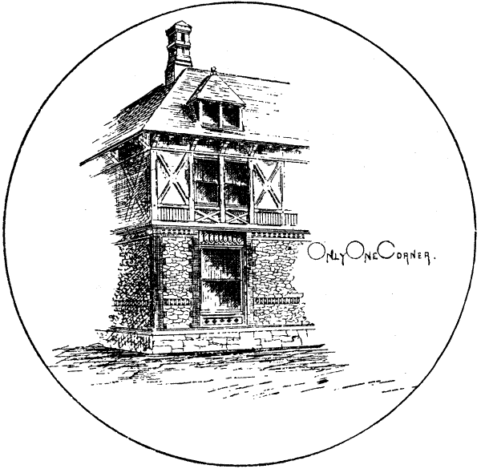
IN LETTERS BETWEEN AN ARCHITECT AND A
FAMILY MAN SEEKING A HOME.

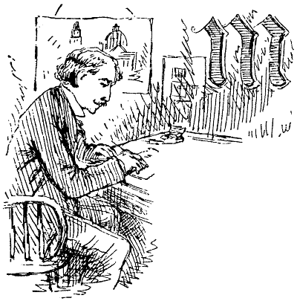

LETTER I.
From the Architect.
EVERY MAN SHOULD HAVE A HOME.

My Dear John:
Now that your "ship" is
at last approaching the harbor, I am confident your first demonstration in honor of its
arrival will be building yourself a house; exchanging your charmingly good-for-nothing
air-castle for an actual flesh-and-blood, matter-of-fact dwelling-house, two-storied and
French-roofed it may be, with all the modern improvements. In many respects, you will
find the real house far less satisfactory and more perplexing than the creation of your
fancy. Air-castles have some splendid qualities. There are no masons' and carpenters'
contracts to be made, no plumbers' bills to be vexed over, the furnaces never smoke, and
the water-pipes never freeze; they need no insurance, and you have no vain regrets over

mistakes in your plans, for you may have alterations and additions whenever you
please without making a small pandemonium and eating dust and ashes while they are in
process. Nevertheless, I have no doubt you will plunge at once into the mysteries and
miseries of building, and, knowing your inexperience, I cannot at such a juncture leave
you wholly to your own devices.
It is a solemn thing to build even the outside of a house. You not only influence your
fellow-men, but reveal your own character; for houses have a facial expression as marked
as that of human beings, often strangely like their owners, and, in most cases, far more
lasting. Some destroy your faith in human nature, and give you an ague chill when you
pass them; others look impudently defiant, while many make you cry out, "Vanity of
vanities!" If you are disposed to investigate the matter, you will find that the history of
nations may be clearly traced in the visible moral expression of the homes of the
people;—in the portable home-tents of the Arabs; the homely solidity of the houses in
Germany and Holland; the cheerful, wide-spreading hospitality of Switzerland; the
superficial elegance and extravagance of France; the thoroughness and self-assertion of
the English; and in the heterogeneous conglomerations of America, made up of
importations from every land and nation under the sun,—a constant striving and
changing,—a mass of problems yet unsolved.
A friend once said to me while we were passing an incurably ugly house, "The man
who built that must have had a very good excuse for it!" It was a profound remark, but if
that particular building were the only one needing apology for its ugliness, or if there
were no common faults of construction and interior arrangement, I should not think you
in special need of warning or counsel from me. There are, however, so many ill-looking
and badly contrived houses, so few really tasteful ones, while year after year it costs more
and more to provide the comfortable and convenient home which every man wants and
needs for himself and family, that I am sure you will be grateful for any help I may be
able to give you.
We are told that all men, women, and children ought to be healthy, handsome, and
happy. I have strong convictions that every man should also have a home, healthful,
happy, and beautiful; that it is a right, a duty, and therefore a possibility. Small and
humble it may be, cheap as to cost, but secure, refined, full of conveniences, and the
dearest spot on earth, a home of his own.
In the hope of making the way to this joyful consummation easier and plainer for you,
I propose to give you a variety of hints, information, and illustrations relating to your
undertaking, and will try to make my practical suggestions so well worth your attention

that you shall not overlook what I may say upon general principles. There is a right
and a wrong way of doing almost everything. I am yours, for the right way.

LETTER II.
From John.
A GRATEFUL CLIENT.

MY DEAR ARCHITECT: How did you know my ship was coming in? Queer, isn't it,
that when a man does get a few stamps, his friends all find it out, and can tell him just
what he ought to do with them. But you're right. I've lived in an air-castle long enough.
It's altogether too airy for cold weather, and a house of my own I'm bound to have. Your
information and advice will be exactly in order; for it is a fact, that, until a man has built
at least one house for himself, he is as ignorant as the babe unborn, not only of how to do
it, but, what is ten times worse, ignorant of what he wants to do. So go ahead by all
means; make a missionary of yourself for my benefit. Don't get on your high heels too
soon, and undertake to tell me what won't be of the slightest use unless I have a fortune to
expend.
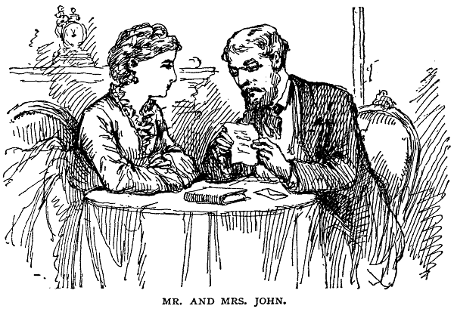

Give me something commonplace and practical, something that I can apply to a "villa"
of two rooms if my ship happens to be empty. I suppose it's all true that an ugly-looking
house is a sign of want of wit rather than want of money, but there are lots of people who
haven't either, precious few that have both. At all events, the man who has only one
thousand dollars to spend is just as anxious to spend it to the best advantage as he who
has five thousand or fifty.
Mrs. John is delighted. She is bent on the new house, but knows I shall get everything
wrong end first from cellar to attic. I always supposed a good kitchen was a desirable part
of a family establishment, but the chief end of her plans is bay-windows and folding
doors. However, if you tell us to put the front door at the back side of the house, or do any
other absurd thing, it will be all right.
As to your preachment on general principles, I'll do the best I can with it; but don't
give me too much at once.
Yours,
JOHN.

LETTER III.
From the Architect.
THE BEAUTY OF TRUTH AND UTILITY.

Dear John: I am glad my efforts in your behalf are likely to be appreciated, especially
if you share this common opinion of architects, that their mission is accomplished when
they have made a pretty picture, and that they are an expensive luxury, which the man
who would build himself a house must forego if he would be able to finish. Greater
durability, comfort, and convenience are not expected on account of their assistance, only
that the house shall be more surprisingly beautiful. Doubtless there is some ground for
this poor opinion, but the architects are not alone in their folly, or wholly responsible;
they attempt to supply an unreasonable demand, and are driven to employ unworthy
means.
The first grand lesson for you to learn (you must have patience with a little more
"preachment") is that the beauty of your building cannot be thrust upon it, but must be
born with it, must be an inseparable part of it, the result and evidence of its real worth.
We must forget our great anxiety as to how our houses shall be clothed, aiming first to
make them strong and durable, comfortable and convenient, being morally certain that
they will not then be disagreeable to look upon. Professing a great contempt for a man
who tries to seem something better and wiser than he is, let us be equally severe in
condemning every building that puts on airs and boldly bids us admire what is only fit to
be despised. The pendulum seems to have swung away from the plain, utilitarian mode of
building that was forced upon our ancestors by a stern necessity,—possibly chosen from a
sense of duty,—to the other extreme; giving us, instead of the old-time simplicity, many a
fantastic design that claims admiration for its originality or its modern style. The notion
that there can be a mere architectural fashion, having any rights that intelligent people are
bound to respect, is quite absurd. Improved modes of construction and new helps to

comfort and convenience are constantly invented, but one might as well talk of the
latest fashions for the lilies of the fields or the stars in the heavens, as of a fashionable
style in architecture or any other enduring work of art. Whatever building is nobly and
enduringly useful, thoroughly adapted to its uses, cannot be uncomely. Its outward beauty
may be increased by well-contrived disposition of materials, or even added details not
strictly essential to its structure; but, if rightly built, it will not be ugly without these
additions, and beware of using them carelessly. What might have been a very gem of
homely and picturesque grace, if left in modest plainness, may be so overburdened with
worthless trash that its original expression is lost and its simple beauty becomes obtrusive
deformity. Even conspicuous cheapness is not necessarily unpleasant to see, but don't try
to conceal it by forcing the materials to seem something better than they are. Let wood
stand for wood, brick for brick, and never ask us to imagine a brown-stone value to
painted sheet-iron. There is, too, a deeper honesty than mere truth-telling in material; a
conscientiousness of purpose, an artistic spiritual sense of the eternal fitness, without
which there can be no worthy achievement, no lasting beauty.
Accepting this doctrine, which cannot be too often or too strongly urged, although it is
not new,—indeed, it is old as the universe,—you will, I think, be puzzled to find an
excuse for yourself if you disfigure a charming landscape or a village street by an uncouth
building. Build plainly if you will, cheaply if you must, but, by all that is fair to look upon
or pleasant to the thought, be honest. It will require some study and much courage, but
verily you will have your reward, and I for one shall be proud to write myself your
admiring friend.

LETTER IV.
From John.
PROFESSIONAL FOLLY.

My Dear Architect: I've been trying to learn my "first grand lesson," as laid down in
your second epistle to yours truly. About all I can make of it is: Firstly, that my house is
for myself to live in,—wife and babies included,—not for my neighbors to look at; and,
secondly, that however much I may try to humbug my fellow-sinners in other ways, I'm
not to build a lie into my house, where it is sure to be found out, after I'm dead and gone,
if not before.
You wonder what my opinion is of architects. Well, without being personal, I'm free to
maintain that as a rule I'm afraid of 'em. The truth is, they don't care what a fellow's house
costs him, whatever they may say in the beginning; and I never knew a man to build from
an architect's plans that his bills didn't come in just about double what he laid out for.
They want to get up a grand display, if it's a possible thing, so everybody that comes
along will stop and say, "What a charming house! Who made the plans?" while from
beginning to end it may be all for show and nothing for use, and mortgaged to the very
chimney-tops. That's my opinion, and I'm not alone in it, either.
There was my neighbor down the road,—he wanted a commonish kind of a house.
Nothing would do but his wife must have it planned by a "professional" man. Result was,
she had to put her best bedstead square in the middle of the room, and there was no
possible place for the sitting-room lounge but to stand it on end behind a door in the
corner. Another acquaintance of mine had $5,000. Didn't want to spend a cent more than
that. Called on an architect,—may have been you, for all I know; architect made sketches,
added here a little and there a good deal, made one or two rooms a few feet bigger, poked
the roof up several feet higher, and piled the agony on to the outside, until, when the thing
was done, it cost him $11,000! Of course it ran him into debt, and most likely will be sold
at auction. He'll never get what it cost him, unless he can sell it as we boys used to swap
wallets,—without looking at the inside. But everybody says it's "lovely," and wants to
know who was his architect.
That, I expect, is just where the shoe pinches. If an architect can only make a fine
show with another man's money, he gets a reputation in no time; but if he has a little
conscience, and tries to plan a house that can be built for a given sum, every one says it
looks cheap, no kind of taste, and very likely the owner himself is grouty about it, and
next time goes for another man.
I don't envy you a bit. But don't be discouraged.
Yours,
JOHN.

LETTER V.
From the Architect.
BUILDING-SITES AND FOUNDATION-WALLS.

DEAR JOHN: You seem to have made as much of my last letter as could reasonably
be expected. I might reply to your unfortunate experience with architects, by describing
the cost and annoyance of the subsequent alterations, almost inevitable whenever a house
is built without carefully studied plans; and I do assure you that when the cost of a house
exceeds the owner's estimates, it is simply because he does not know his own mind
beforehand, or stupidly fails to have his plans and contracts completed before he begins to
build. It's no more the fault of the architect than of the man in the moon. By and by you
shall have a chapter on the whole duty of architects, as I understand it, but not until I have
given you something more practical to think of and possibly to work upon.
Nothing astonishes me more than the absurdly chosen sites of many rural and
suburban dwellings, unless it is the dwellings themselves. Notwithstanding our great
resources in this respect, all considerations, not only of good taste and landscape effect,
but even of comfort and convenience, are often wholly ignored. For the most trivial
reasons, houses are erected in such locations and of such shapes as to be forever in
discord with their surroundings,—a perpetual annoyance to beholders and discomfort to
their occupants. I will not at present pursue the subject, but shall assume that the ground
whereon your house will stand is at least firm and dry; if it isn't, no matter how soon it
falls, it won't be fit to live in. Any preparation for the foundation in the way of puddling
or under-draining will then be quite superfluous.
Unless you are obliged to economize to the uttermost, let your cellar extend under the
whole house, and make it of good depth, not less than 7-1/2 feet,—8-1/2 is better. When
this is ready, I suppose you will start for the nearest ledge, and bring the largest rocks that
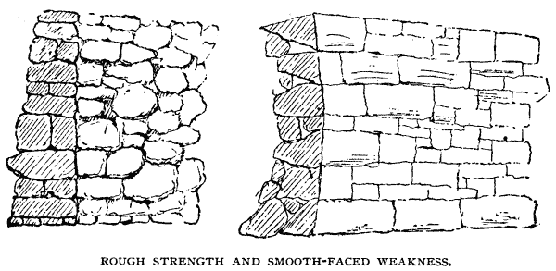
can be loosened by powder or dragged by oxen, and set them in solemn array around
the cellar, their most smiling faces turned inward. If you can find huge flat stones of one
or two yards area, and six to twelve inches thick, you will feel especially fortunate. In
either case you will survey these with admiration, and rejoice in thinking that, though the
rains may fall, and the floods and the winds beat upon it, your house will rest on its
massive support in absolute security, never showing the ugly cracks and other signs of
weakness that spring from imperfect foundations. Perhaps not, but it will be far more
likely to do so than if the first course of stones in the bed of gravel or hard pan are no
larger than you can easily lift. You cannot give these huge bowlders such firm resting-
place as they have found for themselves in the ages since they were dropped by the
dissolving glaciers. However you handle them, there will be cavities underneath, where
the stone does not bear upon the solid ground. The smaller ones you may rub or pound
down till every inch of the motherly bosom shall feel their pressure. Upon this first course
of—pebbles, if you please, lay larger ones that shall overlap and bind them together,
using mortar if you wish entire solidity. As the wall rises, introduce enough of large size
to bind the whole thoroughly. Above the footing the imperfect bearings of the larger
stones are of less consequence, since there is little danger of their crushing one another.

I say you will probably set their smooth faces inward, where they can be seen, which
is quite natural and well enough, provided this is not their only merit. If behind there is a
lame and impotent conclusion, a tapering point on which it is impossible to build without
depending upon the bank of earth, it will be better to have less beauty and more strength.
I don't like a foundation wall that is "backed up"; it should be solid quite through; if any
difference, let it be in favor of the back or outside. You will find plenty of walls bulging
into the cellar, not one crowding outward.

If the footing of a foundation is made as it should be, the upper part may be much
thinner, since there is no danger of crushing it by any probable weight of building. It may
be crowded inward by the pressure of surrounding earth, especially if the building is of
wood. To guard against this, interior buttresses of brick, or partition walls in the cellar,
will perhaps cost less than a thicker main wall. The buttresses you may utilize by making
them receive shelves, support the sides of the coal-bin, etc., while the partitions will take
the place of piers, and, if well laid, need be in smaller houses but four inches thick.
Should your cellar happen to be in a gravelly knoll,—you are thrice and four times
blessed if it is,—and if there is a stony pasture near it or a quarry from which you can get
the chips, you may try a concrete wall of small stones, gravel, and cement. It will be
strong and durable; with a wheelbarrow you can make it yourself if you choose, and the
rats will despise it.
Whether your house is one story or ten, built of pine or granite, you can have no better
foundation than good hard brick laid in cement mortar; cellular above the footing, as
brick walls should usually be made. Between this and stone it will be then a question of
economy to be determined by local circumstances.
The
details
and
accessories
of
cellars,
their
floors,
ventilation,
and
various
conveniences, belong to the interior equipments. There is, however, one point that even
precedes the foundation,—the altitude. As the question commonly runs, "How high shall
the top of the underpinning be?" Of course this can only be given on an actual site. It is
unfortunate to plant a house so low in the ground that its cellar forms a sort of cesspool
for the surrounding basin; most absurd to set it up on a stilted underpinning until it looks
like a Western gatepost, lifted every year a few inches out of the ground by the frost, till it
finally topples over and has to be set anew. Two things you will notice in locating your
house,—as soon as the walls and roof are raised, the distance to the street in front will
seem to be diminished, and the ground on which the building stands will appear lower
than before, lower than you expected or desired. There is so much said and sung about
houses being set too low, that it is quite common to find them pushed out of the ground,
cellar and all, as though this would atone for a want of elevation in the land itself. There
is little danger that you will place your house too high, great danger that you will not raise
the earth around it high enough. Be sure that after grading there shall be an ample slope
away from the walls; but whether you will have a "high stoop," or pass from the dooryard
walk to the porch and thence to the front hall by a single step, will depend upon the
character of the house and its surroundings. To express a generous hospitality the main
entrance should be so convenient and inviting that it seems easier to enter than to pass the

door. This effect, especially in large rambling houses, is most easily obtained by
keeping the first floor near the ground. That hospitality and good cheer will always be
found beneath your roof is my earnest wish.

LETTER VI.
From John.
GRAVEL-BANKS AND QUAGMIRES.

MY DEAR ARCHITECT: I'm all right on the gravel question. You don't catch me
building in anybody's quagmire. There's plenty of rheumatism and fever 'n' ague lying
around loose without digging for 'em, and then building a house over the hole to keep 'em
in. I don't want to say anything against any man's building-lots, but how in the light of
common-sense a man can, with his eyes open, build his shanty on some of the streets in
your enterprising city, is too much for my understanding. If they would first put in good
big sewers, running slick and clean to the river, and underdrain the whole premises, 't
wouldn't be quite so bad. But I don't want them, anyway; give me the high land and the
dry land. I'm not particular about founding on a rock, either; that was well enough in old
times when they didn't want cellars, but let me have a good bed of sand or gravel. Cellar
may not be quite so cool, but all we need is to go down a little deeper, while, as for
health, I'd rather be ten feet under ground in such a spot than occupy the "second-story
front," in some places I could mention.
Your foundation is all right in theory, and if I was going to put up a steam chimney, a
government building, or anything else that must be done in the best way, regardless of
expense, I should go for it. For cheap, common work, 't isn't worth while to be over-nice
or over-wise. I tell you, there is danger of knowing too much about some things.
According to your notion, a man couldn't do better than to stick the ground full of
tenpenny nails to start with, and I should think a thousand-legged worm would be about

the most substantial animal that treads the globe.
As to planting my house, when I've bought the lot, I'll ask you to take a look at it. I
have a fancy for some sort of a sidehill, so I can get into my house, from one side at least,
without going up stairs out of doors, and still have the first floor airy and dry.
Yours,
JOHN.

LETTER VII.
From the Architect.
NATURE'S BRICKS ARE BETTER THAN OURS.

DEAR JOHN: Where to build your house may be, in truth, a question quite as
important as how to build it. I regret my inability to give you the advice you need. Dr.
Bowditch has, I think, intimated that there is an elysian field not far from here of such
rare sanitary virtue that if its locality were known there would scarcely be standing-room
within its borders for those who would flock thither, or something to that effect. I trust we
shall some time have a scientific practical investigation of the whole matter, and such
definite information as will enable us at least to qualify, by artificial means, evils that
cannot, in thickly settled regions, be wholly avoided. Meantime stick to your text, keep
high and dry. If you are bound to have a sidehill, and can find none to suit, you can
doubtless make one of the earth thrown from the cellar wherever you locate.
Have you decided what materials to use, whether wood, brick, or stone? You will
hardly use any other. Glass houses are not popular, although for their sunlight they ought
to be; paper ones are not yet introduced among us,—I'm expecting them every year; and
iron, important and useful as it is, and destined to become more so, is not adapted to such
buildings as yours. Wood, brick, or stone, then,—which of the three? To spare you all

possible confusion, we will take them separately and in order, beginning with the
hardest.
For rural dwellings in New England stone is rarely used, except for foundations below
ground, being, according to the common notion, better for that purpose than brick, but not
as worthy to be seen, unless hammered and chiselled into straight lines and smooth
surfaces. Errors both. Well-burned brick laid in cement mortar are nearly always as good
as a stone foundation, while nothing can be more effective in appearance than a well-laid
wall of native, undressed stone. We have too long neglected one of the most available of
our resources in not making use of the small loose stones that abound in many localities.
They are cheaper and better than bricks, and, rightly used, so thoroughly in harmony with
the nature around them that we should find them in common use if men were half as wise
in accepting the means of grace provided for them as they are prone to seek out many
inventions. The earlier farmers with enormous industry built them into fences, and then
added a second story of wood to keep the sheep from walking over them, or piled them up
in conical heaps, watch-towers for the woodchucks. The later farmers, with less patience
but possibly more enterprise, are running away from them to the smoother fields and
richer mould of the Western prairies. We can do better than either; for, wherever found,
they may be used most favorably, not only for foundation walls that are deeply hidden
from mortal view, but for the main walls of the entire building,—favorably, not only in
point of economy and strength, but with most admirable result as to external appearance.
And here you touch your fundamental principle, that the best outward effect can only be
obtained by a judicious use of the materials with which you build. You must not make the
walls without any reference to their composition or proportions, and then try to conceal
the poverty and awkwardness of the structure by pinning up preposterous window-caps,
hanging horrible brackets under the eaves that must always be in doubt whether they
support the cornice or are supported by it, fixing fantastic verge-boards to the gables, and
covering the roof with wooden knick-knacks that mock consistency and defy description.
Look rather to the materials at your command, and, whatever they may be, try to dispose
them in such way that, while each part performs a legitimate, necessary service, you shall
still have variety and harmony.
Because I have suggested building your main walls of natural undressed stone, you
must not attempt to construct them of that alone. The main corners, the door and window
jambs, the caps and sills, cannot well be made of these rough hard heads and cobbles that
are scattered over the fields, or from quarry chips. And here will arise the question of
cost. It would seem decidedly grand to use for the corners substantial blocks of hewn
stone,—sandstone, granite, marble, or porphyry,—channelled and chamfered, rock-faced,

tooled, rubbed, or decorated; key-stones and voussoirs embellished with your
monogram or enriched by any other charming device you choose to invent; bands of
encaustic tile, brilliant in color and pattern, belts of sculptured stone, and historic
tablets,—if you fancy and can afford them. Unless your ship is heavily freighted with
Australian gold or African diamonds, by all means dispense with the cut stone, and use
brick for the corners, caps, and jambs, and some good flag-stones broken into strips of
suitable width and thickness for the sills and belt-courses. This will give you a contrast in
color (unless you have the reddest of red sandstone for the walls), the utmost economy
and durability of construction, and a whole effect very likely better than that of the stone.
These brick dressings may be light, especially the jambs; but the corners, at least, should
be laid in such fashion as to bind well into the stone walls, and if of considerable height,
should be strengthened by belts of stone, or iron anchors running through the brick and
extending into the main wall several feet each way. Any large blank surface may be
relieved by a little ingenuity in the selection of the stones for the main walls, introducing,
perhaps, some of regular shapes and size, the raised mortar, which may be colored dark or
red, marking the joints, or inserting a belt of different color. Horizontal bands of brick
laid in fancy pattern may be convenient and effective.
Of course you will not adopt this style of wall unless there is a crop of suitable stones
within easy distance. It is more probable that you will be afraid to use what you have than
that there are none to use. Whatever can be made into a stone fence will make the walls of
a house, if you are not too ambitious of height, and do not attempt to make them too thin.
Other things being equal, the thicker the walls, within certain limits, the better. You don't
care to build a Bastile, but deep window-jambs without and within add wonderful
richness and dignity. If the walls cost little or no more, as is often the case, it is a pity to
refuse the additional ground required for their extra thickness. Such walls should not be
monopolized by hundred-thousand-dollar churches and fancy summer residences. They
are quite suitable for the simplest, most unpretending country homes.
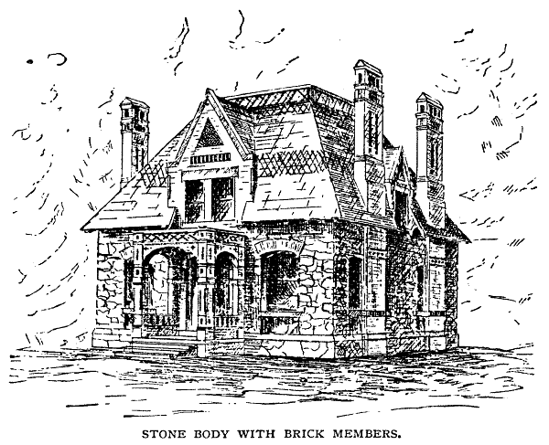

You will understand the general idea thus far by the accompanying sketches, with
which I must close this letter, without concluding the subject.

LETTER VIII.
From John.
THERE IS A SOFT SIDE EVEN TO A STONE WALL.

MY DEAR ARCHITECT: I'm slowly digesting your last production; not being an
ostrich, it goes rather hard. For all that, it may be worth thinking of. Perhaps I shall be
converted by the time the subject is fully shown up. I suppose we've always looked upon
these loose rocks and stones sprinkled about the country as a part of the original curse,
and have never thought of turning them to any sensible use, though good old Dr. Hopkins
seemed to have faith that their soft side would some time be discovered. Funny, isn't it,
that we should burn so much fuel and spend so much labor making bricks and other
artificial building-blocks, when there are piles of them ready made, that would only cost
the hauling? Not always on the square, to be sure, although in some places the ground is
full and running over with flat stones that can be laid up as easily as shingles. They would
hardly need any mortar, and the brick trimmings you describe would be a nuisance,
except for looks. Miles and miles of stone-walls you will see, up and down hillsides and
across pastures that don't look worth their taxes. Once in a while the lower half of a cider-
mill, the back side of a barn-yard shed, or something of that sort, is made of them; but the
people in these parts seem to think it would be folly to use them for anything more
dignified. I suppose, because they are too simple and natural,—just as the Almighty made
them.
These square-cornered, flat-sided fellows are not the commonest kind, however; and
I'm free to maintain that I don't want to build my house more than seventy-five feet high
of the smooth cobbles that will scarcely hang together in a respectable stone-heap. I
should expect the whole thing would come tumbling down some rainy night.
Mrs. John don't take to the notion of a stone house—not yet. Says they 're wofully old-
fashioned and poky,—look like Canadians and poor folks. I just keep still and let her
talk,—it's the best way.
Won't such walls be cold and damp? How am I to know whether the stones that I can
find are fit to use? Send you a boxful by express?
Yours,
JOHN.

LETTER IX.
From the Architect.
A BROAD HOUSE IS BETTER THAN A HIGH ONE.

MY DEAR JOHN: It will not be necessary for you to send me a stone-heap or a
section of pasture-wall for inspection. I would rather venture an opinion from your
description.
Of course, these walls alone, if solid, as they doubtless must be, will be cold and
damp; they must be furred off within to prevent moisture from condensing on the walls of
the rooms. This furring should be done with light studs, secured to the floor timbers
above and below, having no connection with the stone walls, the inside of which may be
left quite rough, whatever the "builders in the elder days of art" might say to such
negligence. For greater permanence and security against fire, instead of wood furrings
you may build a lining of brick, leaving an air space of several inches between it and the
stone, very much in the same way as if the whole were of brick.
You say you would prefer not to build walls as high as a church tower of smooth
cobblestones. Don't; it wouldn't be wise. Still I have seen them, of more humble
dimensions, laid in good cement, as such walls always should be laid, that seem as firm as
unbroken granite. But you will remember I only advise this mode of building on the
condition that you are not ambitious of height. If you are, by all means curb your
aspirations, or else buy a city house six or seven stories in the air, where you can gratify
your passion for going up and down stairs. There is the best reason in the world why a tall
house in the country should look grim, gaunt, and awkward; it is thoroughly inconvenient
and out of place. The area of arable land covered by human habitations does not yet
interfere with agricultural products. So let us spread ourselves freely. When we have
learned the beauty and the strength of co-operation for mutual helpfulness, we shall see
the prevailing mode of constructing houses in cities very much modified. Now they stand
as books are placed on their shelves,—vertically and edgewise. They would hold just as
many people, and be far more convenient, if they could be laid horizontally, one above
the other.
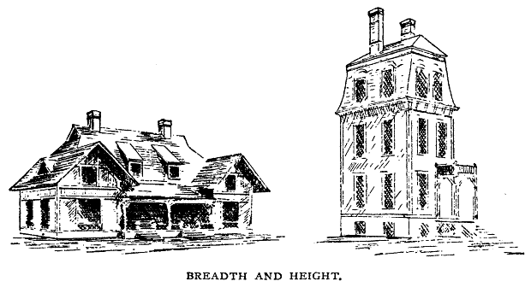
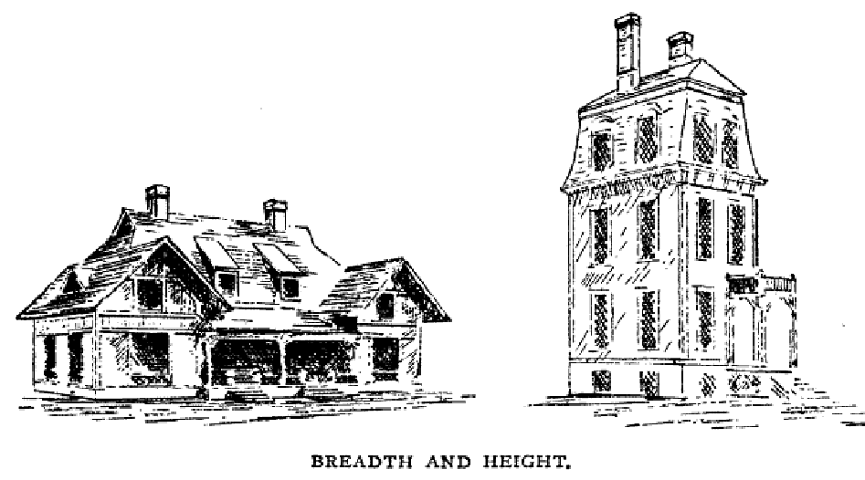
True, this would involve floors impervious to sound, and fire-proof,—by no means a
fatal objection. Since we can neither "fly nor go" in the air, like birds and angels, it is well
for us, having found our appropriate level, to abide thereon as far as may be. There is no
doubt that where dwellings must be built compactly in "blocks," as we call them, the
"flat" arrangement, each tenement being complete on one floor, is the cheapest and best.
Even the fourth story in such a building is preferable to a house of eight or ten rooms, two
on each floor. But this does not concern you, unless you have a few thousands to invest in
tenement-houses. In the right place I like an old-fashioned one-story house, but most
people have a prejudice against anything so unpretending.
One other fact besides the worth of co-operation I hope the dwellers in cities will learn
to recognize practically. When there were no swift and screaming locomotives, no cosey
and comfortable horse-cars, no red and yellow omnibuses even, there was good reason
why men must forego the boon of country air; must forget the color of the ground, the
smell of the green things growing, and the shape of the heavens above them. But the
reason no longer exists. Doubtless the business of a city should be as compact as possible;
but for its dwellings, every consideration of comfort and happiness, of physical and moral
well-being, demands that the inhabitants shall make the most of their migratory resources
and—scatter; find room to build, not tenements or residences, but
homes
for themselves
and their children. In the old time safety was found by crowding together within mural
walls. Now the case is reversed. Where the population is densest, temptations and dangers
do most abound. We've outgrown the walls, let us overcome the evils that were bred

within them.
There may be a prejudice against another quality of these stone walls. They are rough.
Roughness means want of culture and labor; that implies want of money, and that is—
unpardonable. But roughness does not mean any such thing. What are mouldings and
frets and carvings but a roughening of otherwise smooth surfaces? Artists of all kinds
seek to remove even the appearance of an unbroken plane, and nature abhors a flat
exterior, never allows one, even in the most plastic material, if it can be broken. See the
waves of the ocean, the mimic billows on a snow-covered plain, the rugged grandeur of
the everlasting hills. Fancy a pine, an oak, or an elm tree with trunk and limbs smoothly
polished! What if the outside of your walls are somewhat uneven? Let them be so. The
shadows will be all the richer, the vines will cling more closely, and maybe the birds will
hang their nests in some sunny corner. Do not, then, try to improve the natural faces of
the stones with pick and hammer; you will find it hard work, and, very likely, worse than
thrown away.
I think you will like, both in exterior effect and in practical result, the plan of building
the walls of the first story of stone with brick dressings, as described in my last letter,
making the remainder of the house of wood, be the same more or less. If the sketches I
send you do not make you in love with this style, or if you do not like to risk the
experiment, examine something already built before deciding against it. But first explore
the country around you and see if the stony prospect is good.
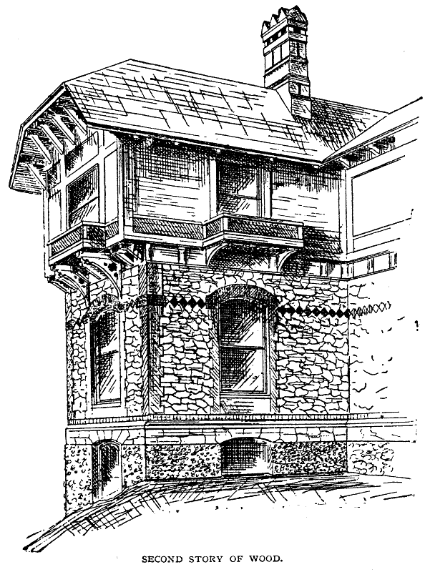

Mr. Donald G. Mitchell not only writes in favor of this mode of building, but proves
his faith by his work; his new house at Edgewood being an admirable specimen of it. You
will find, too, some noteworthy examples at Newport, for which, with much else in the

way of applying a refined taste to rural affairs, we are indebted, directly or indirectly,
to the same well-known writer. If, after the pictures, Mrs. John is still doubtful of the
result, the examples above mentioned will certainly allay her misgivings.
You must not think I would recommend this as a universal fashion, even where the
materials are abundant, but give it place according to its merit.
I hope you will be spared the folly of building your house of dressed stone of uniform
size and color, lest it be mistaken for a large tomb or a small jail. That you may not at
present be compelled to take up your abode in either, is my sincere wish.

LETTER X.
From John.
TROUT BROOKS ARE BETTER THAN STREET SEWERS.

My dear architect: We read, we saw, and—were conquered. The pictures, the
arguments, and especially the illustrious examples, brought down the house, or rather
brought it up. Mrs. John is not only fully reconciled to stone walls, but she is decidedly
unreconciled to any other,—that is, for the first story; the second story is to be of wood,
the walls shingled or slated instead of being covered with clapboards, in the orthodox
fashion. She is delighted with the notion that her "Baltimore belles" and the like can
clamber against the house without being torn away every two or three years for paint. On
the strength of this notion, she has already ordered a big lot of all sorts of herbs and
creeping things, from grape-vines and English ivy to sweet-peas and passion-flowers.
That's only one thing. Every time we go out to ride she gathers up from the wayside such
a load of small rocks as makes the buggy-springs ache. We found a smooth round stone,
yesterday, that looks so much like my head she declares it must be a fossil, and is bound
to have it set over the front door instead of a monogram. We follow your lead in another

direction; if we can't rise in the world without going up stairs for it, we'll try to
cultivate the meek and lowly style.
Your best point, according to my thinking, is on the migration question. I read that
paragraph over twice, and stuck a pin at the end of it. It doesn't concern me, to be sure;
but I have the utmost pity for a man who is content to live all his life shut in between
brick walls. To undertake to bring up a family of boys and girls where all the blessed
freedom of out-door life is denied them, is worse than pitiful,—it's heathenish. Not that
every boy ought to live on a farm and work in a barn-yard,—hoe corn all summer and
chop wood all winter,—but I don't believe a child can grow up strong, healthy, and
natural, body-wise and soul-wise, unless he has a chance to scrape an acquaintance with
Mother Nature with his own hands. When I stake out John City it will be a city of
magnificent distances, in the form of a Greek cross,—two wide streets crossing each
other at right angles in the middle; all the business at the "four corners," where there will
be plenty of short cross streets; the dwellings stretching away for miles on the two broad
avenues; house-lots one to ten acres; Union Pacific Railroad will cut through the centre
corner-wise; and the Metropolitan Transportation Company, or something else with a big
name, will run elegant cars like shuttles through the two main streets, and Mrs. A at the
West End can call on Mrs. B at the North, South, or East End, ten miles away, with less
trouble than you in your city can go from Salem to Howard Street.
Similarly, Springfield ought to stretch from Longmeadow to Chicopee Street, from
Indian Orchard to Agawam. At all events, if your folks will make the most of their
opportunities, it will some day be one of the most charming inland cities on the continent.
Whether there is good sense, public spirit, and patriotism enough to make it so remains to
be seen.
Yours,
JOHN.

LETTER XI.

From the Architect.
THE STRENGTH AND DURABILITY OF BRICK.

My dear John: It is encouraging to know that my suggestions find some favor in your
sight. Pray don't go too fast. It isn't well to make up our minds fully until we have heard
all sides, lest we have them to unmake, which is always more or less painful.
Notwithstanding the peculiar merits of the stone walls, the coming house,—the house
that is to embody all the comforts and amenities of civilized life,—the house of safe and
economic construction, well warmed, well ventilated, defiant alike of flood, frosty and
fire,—the millennial house, if you please, will doubtless be a brick one. Don't be alarmed.
I know just what vision rises before your mind's eye as you read this. A huge square
edifice; windows very high from the ground, not very large, square tops, frame and sash
painted white; expressionless roof; flat, helpless chimneys perched upon the outer walls,
the course of their flues showing in a crooked stain; at the back side a most humiliated-
looking wooden attachment, somewhat unhinged as to its doors and out at the elbows as
to its windows, evidently hiding behind the pile of brick and mortar that tries to look
dignified and grand, but only succeeds in making a great red blot on the landscape; all the
while you know the only homelike portion of the establishment is in the wooden rear part.
The front rooms are dark and gloomy, the paper hangings are mouldy, the closets musty
and damp; there is a combined smell of creosote and whitewash pervading the chambers,
and the ceilings hang low. I don't wonder you object to a brick house in the country. Yet,
if you propose to build a model, honest and permanent, a house that shall be worth what it
costs and look as good as it is, I shall still recommend brick. The growing scarcity of
wood, the usual costliness of stone, the abundance of clay, the rapidity with which brick
can be made and used,—one season being sufficient to develop the most awkward hod-
carrier
into
a
four-dollars-a-day
journeyman
bricklayer,—the
demand
for
more
permanence in our domestic dwellings, and the known worth of brick in point of
durability and safety,—all these reasons will, I think, cause a steady increase in their use.
Hence it behooves us to study the matter carefully, and see whether any good thing can be
done with them.
Since the time, long ago, when the aspiring sons of Noah said to one another, "Go to;
let us make brick and burn them thoroughly," to the latest kiln in Hampden brick-yard,
there seems to have been little variety in the making or using of them, except that among
different nations they have assumed different forms. They are found as huge blocks a foot

and a half square, and in little flinty cakes no bigger than a snuff-box. The Romans
made the best ones, some of their buildings having defied the elements for seventeen
centuries, and their mantle, as to brickmaking, has fallen upon the Dutch. They were
found among the ancient Peruvians, and the Chinese made beautiful the outside of the
temple by giving a porcelain finish to the brick. Still I fancy they have always been more
famous for their use than for their beauty; but their utility is beyond all question. If our
modern experience doesn't prove it, read this inscription from an ancient brick pyramid of
Howara:—
"Do not undervalue me by comparing me with pyramids of stone; for I am better than
they as Jove exceeds the other deities. I am made of bricks from clay, brought up from the
bottom of the lake adhering to poles."
Notwithstanding these claims to veneration, there is but little poetry about them, and
therefore, I suppose, but little progress. Compared with other materials, they have
undergone slight changes with us, in color, shape, or modes of use. A block of wood or
stone contains, in the eye of the artistic workman, every possible grace of form and
moulding; but a brick is a square, red, uninteresting fact, and the laying of them the most
prosaic of all work. By common consent we expect no improvement in their use, but
rather sigh for the good old times when work was honestly done and the size of the brick
prescribed by law. We associate them with factories, boarding-houses, steam-chimneys,
pavements, sewers,—whatever is practical, commonplace, and undignified. Yet there are
charming, even delicate, effects possible with these unpromising rectangular blocks.
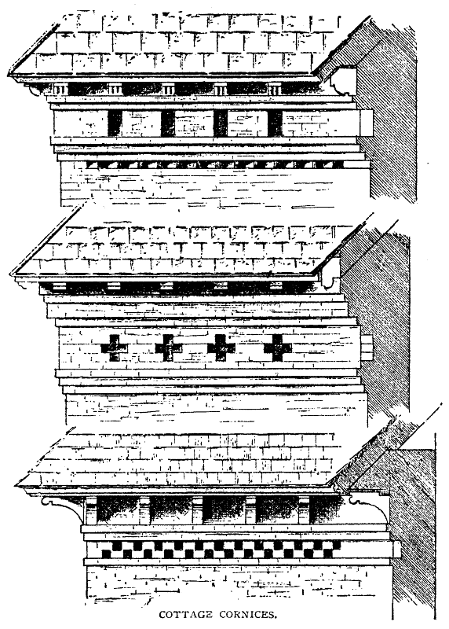

In your efforts to unite beauty and brickwork it will be well to begin modestly, merely
aiming to avoid positive ugliness. Do not feel bound to enclose your house by four
straight unbroken walls,—brick are no more difficult to build in irregular shape than
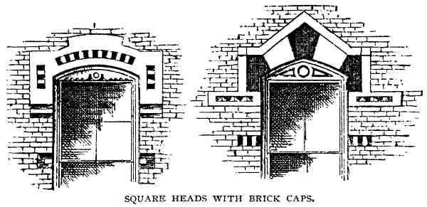
anything else,—and do not, on any account, make square-topped openings, as the
builders of the old-fashioned brick houses were wont to do. Doubtless you have read Mr.
Ruskin's vigorous protest against this particular architectural sin; if you have not, by all
means do so, only he proves too much, and would fain make us believe that our doors and
windows must not only be crowned by arches, but they must be Gothic arches,—doctrine
to be received with some grains of allowance. A pointed Gothic arch may be, often is,
very beautiful; but, applying our test of utility, it is most obviously out of place, and
therefore inartistic, where close economy, convenience, and abundance of light are
required. For the sake of strength, if for no other reason, let the top of the openings be
arched, but a low arch of one arc or two is often preferable to a high one. If, for
economy's sake, you wish to make the top of the sash square, do so, curving the upper
portion of the frame as a sort of centre on which the masonry may rest; but do not attempt
this if the openings are wide, and in any case relieve the wood segment by ornamental
cutting or some other device, otherwise you will have a weak and poverty-stricken effect.
Or you may use a straight lintel of stone, taking care to build a conspicuous, relieving
arch above it of stone or colored brick. You will get the idea from the sketches, and see
that there is room for endless variety of expression and ornament without violating any of
the first principles, which you will do if you try to cover a square-headed opening with a
"straight arch" of brick, or leave a light, horizontal stone cap without a protecting arch
above it.

LETTER XII.
From John.
THE WEAKNESS AND SHAM OF BRICKWORK.

My Dear Architect: You must have had a brick in your hat when you launched your
last letter. I suppose there's no doubt that brick walls will stand thunder and lightning in
the shape of Chicago fire and Boston gunpowder better than anything else. In fact, I've
always had a notion that if there are any houses in a certain place where they don't need
them to keep out the cold, they must be made of brick, Milton's gorgeous testimony to the
contrary notwithstanding. But when you undertake to show up the softness and beauty of
brickwork, you soar a little too high for me. If our masons would only make walls that are
able to bear their own weight; not use more than half as much mortar as brick, and that
made of sand instead of dirt; if they would build chimney-flues that will carry the smoke
to the top of the building, instead of leaving it to ooze out around the window-frames a
dozen feet away, as I once saw it in a costly building belonging to one of our ex-
governors, and remember that a wooden joist running square across a chimney-flue is
pretty sure to get up a bigger draught than most of us care for; if they wouldn't fill up the
inside of the wall with bricks that it isn't safe to drop for fear they can never be picked up
again; in short, if they'd do the work that can't be seen half as well as what is in plain
sight, I'd never say a word about beauty, I wouldn't even ask for those elegant caps the
masons are so fond of poking out over windows. You can find at least ten thousand such
in Springfield. Some folks paint them, sprinkle sand into the paint, and then go on their
wicked way rejoicing in the notion that they have told such a cunning lie as "no feller can
find out."
Now and then the corner of a brick building is cobbled up into blocks and polished off
in the same style. If these are some of the beauties of brickwork, I pray you have me
excused. If you have anything better to offer, go ahead, I'm open to conviction; would

rather be knocked down by an argument than a brickbat any time.
Mrs. John says she doesn't care a straw about bricks, and hopes you won't spend much
time talking about them. She's bound to have a stone house, whether or no, and wants you
to give us your notions about inside fixings, especially the kitchen. (Between you and me,
she wouldn't have said a word about the kitchen, if I hadn't accused her of caring for
nothing but bay-windows and folding-doors.) Her sister Jane has been over to see her, and
they've had a host of projects to talk over; part of 'em I get hold of and part of 'em I don't.
Jane isn't married, but she's got some capital notions about housekeeping. Great on having
things nice and handy inside, especially for doing the work, but she don't care much for
the outside looks. So she hopes you will get out of the brick-yard as soon as possible. Of
course, I shall read what you have to say whether they do or not, but don't run wild on the
subject.
Yours,
JOHN.

LETTER XIII.
From the Architect.
SKILL DIGNIFIES THE MOST HUMBLE MATERIAL.

Dear John: Please tell Mrs. John and Sister Jane that I am as anxious to get into the
kitchen as they are to have me; and if I can succeed in giving suggestions that shall make
the domestic work, on which our comfort and happiness so largely depend, easier and
pleasanter,—restoring the wellnigh lost art of housekeeping to its native dignity,—it will
be a grander achievement than designing the most beautiful exterior that ever adorned a
landscape. I'm perfectly aware that the outside appearance of the house is to the interior
comfort thereof as the body to the soul,—no comparison possible between the two. Still,

they must possess their souls in patience and allow me to work according to my own
plan. Moreover, they must not neglect a careful study of the brick question. A decided
opinion is a good thing, provided it is grounded on the truth; otherwise it is a stumbling-
block.
For yourself, I assure you my head is level; would that all brickwork were equally so.
Beauty and bricks are not incompatible; but remember, there is one beauty of brick,
another beauty of stone, and another beauty of wood. Do not confound them or expect
that what pleases in one can be imitated in the other. As you were admonished, some time
ago, "be honest; let brick stand for brick," then make the most of them. Your criticism on
a very common form of "brick-dressing" is quite to the point. Aside from the stupid folly
of painting them to imitate stone, not only these window-caps, but all horizontal belts
having any considerable projection are essentially unfit for brickwork. The mortar is
almost sure to fail at the upper side, giving the whole a look of premature decay, even if
well done at first. A level course of long stone, running through a wall of small stones or
brick, gives greater strength by binding the whole together. This has not always a good
excuse for extending beyond the wall-face. But a projecting belt of brick adds nothing
either in appearance or in reality. If horizontal lines are required to diminish the apparent
height of the building or affect its proportions, make them of brick of different color from
those of the main wall or laid in different position. Remember this; fanciful brick
decorations are quite sure to look better on paper than when executed. As a rule, the more
complex the design the greater the discount. Such work is apt to have an unsafe
appearance, as though the whole was at the mercy of the bottom brick.
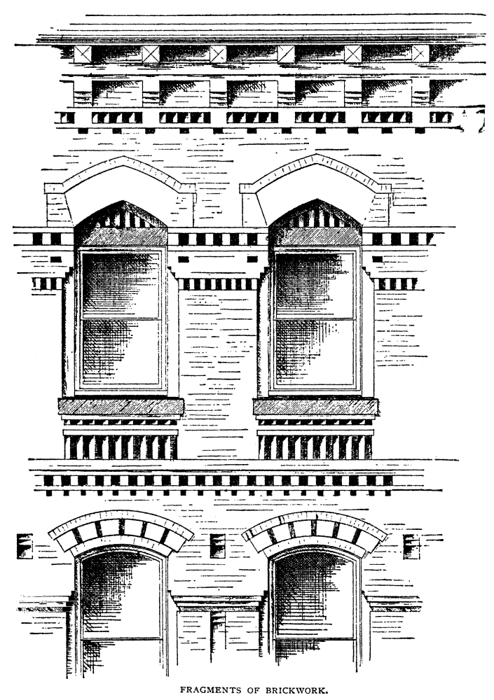

Your own sense of fitness must decide what shall be the general character of your
house, whether light, open, airy, or sober, solid, and dignified. If the latter, let the strength
of the walls be evident. Set the window-frames as far back from the wall-face as possible,
in spite of any obstacles the builders may raise; make the arches above the openings
massive, and the recessed portions of the cornice or any other ornamental work deep and
narrow. There are not the same objections to a recess as to a projection; it is better
protected, any imperfection is less apparent, and the desired effect of shadow is more
complete. Much variety in color will not increase the appearance of strength, but the
expression will be emphasized by pilasters and buttresses; also by the low segment arches
and wide piers.

On the other hand, for a lighter effect, make the windows wider and crown them with
semi-circles or pointed Gothic arches. Leave out the corners of the piers in building them
up; introduce belts of brick laid in various positions and of different colors, if you can get
them, as I trust you may. Indeed, this very season, a brickmaker has reported himself
prepared to furnish black bricks and buff, red bricks and gray, all of good and regular
standing. You may be sure I gave him my blessing, and invited him to press on. I do not
know whether he will prove to be the coming man in this department, but whoever brings
a greater variety of brick in form and color within reasonably easy reach will do a good
work that shall surely have its reward; for brick houses we must have, ugly ones we won't
have, and rich decorations of stone we cannot afford for common use. Meantime, if you
can do no better, do not hesitate to use brick that have been treated to a bath of hot tar.
They may look old-fashioned, by and by. No matter; an old fashion, if it is a good one, is
more to be admired for its age than despised. It is only by reason of its falseness and
inconvenience that it becomes absurd.
In the same category with colored bricks (indeed, they are a sort of spiritualized
bricks) are the brilliant-hued encaustic tile that are finding their way hither across the
Atlantic. Let us hope that the greatest country in the world will not long send three
thousand miles for its building materials. A variety of forms and sizes of bricks we may
easily have when we demand it in earnest. Beyond question there is room for almost
unlimited exercise of fancy in this direction. We only need the taste to design appropriate
shapes and to use them aright. Mr. Ruskin mentions certain brick mouldings as being
among the richest in Italy. The matter of size relates rather to construction than ornament,
but it is very important here. I think it will some time seem as unreasonable to make brick
of but one size and pattern as it would now be to have all timber sawn of uniform
dimensions.
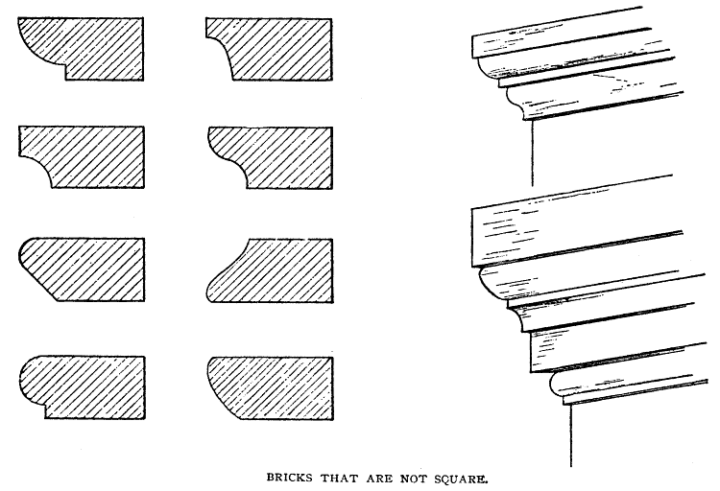

You are more liable to attempt too much in the way of decoration than too little. Don't
make your house look as though it was intended for a brickmaker's show-case. You will
find the simplest designs the best. I have seen a really good effect on the side of a large
building from the mere holes left in the wall by the masons' stagings.
One thing more: Do not become possessed with the idea that a brick house must be a
large or an expensive one. It may be small and cheap, but withal so cosey and domestic,
so thoroughly tasteful and picturesque, that you will have an unquestioning faith in the
possibility and the desirableness of love in a cottage, the moment you behold it. On the
other hand, by making the best of your resources, it is possible to build a large, plain,
square house, a perfect cube if you please, that shall not only be homelike in appearance,
but truly impressive and elegant. How? I've been trying to illustrate and explain. By being
honest; by despising and rejecting all fashions that have nothing but custom to
recommend them; by using colored and moulded brick if you can use them well; by
not

laying the outside work in white mortar, and by exercising your common-sense and
independence, both of which qualities I am sure you possess.
I must beg Mrs. John and Sister Jane (by the way, I'm flattered to know that a notable
housekeeper finds anything promising in what I have thus far written you) not to give up
the ship. One more broadside for the brick-yard, and we will pass on to loftier themes.

LETTER XIV.
From John.
EVERY MAN TO HIS TRADE.

My dear Architect: There is one point you might as well square up before you go any
further. I understood that I was to build my house for myself to live in, not for my
neighbors to look at. But I appeal to any white man, if you haven't had a deal more to say
about the outside of the platter than the contents thereof. To be sure, it's what I might
have expected. It's a way you architects have. You can no more help thinking how a
house is going to look, than a woman can help hoping her first baby will be a beauty. I
allow it would be a first-rate thing if we could have some streaks of originality, just a
trifle more of variety, and a few glimpses of really good taste, along with the crumbs of
comfort; and I'm willing to admit that your moves in that direction, as far as I can follow
them, are all right. Still, it's a downright fact, that, unless a man is a great simpleton or a
small Croesus, he is more anxious to make his house cosey and convenient, than he is to
outshine his neighbors or beautify the landscape.
Sister Jane wants to know whether, in case one wishes to begin housekeeping on a
small scale, it would be as easy to make additions to a brick house for future need, as to a
wooden one. She doesn't ask on her own account, but for a friend of hers who is talking
of building.
I expect you'll inquire pretty soon who's running these letters,—you or I; but if we
don't sometimes show our ignorance by asking questions and making comments, how are
you going to know what sort of information to shed?
Yours,
JOHN.

LETTER XV.
From the Architect.
THE COMING HOUSE WILL BE FAIR TO SEE AND MADE OF
BRICK.

Dear John: Once for all, your questions and those of Sister Jane or any of her friends
and relatives are always in order. The more the better. I will do my best to answer them, if
not exactly by return mail, yet as soon as may be.
Other things being equal, a house built of brick may be as easily increased to suit a
growing family as one built of wood. There is necessarily a loss attending any change in a
finished building, yet it is often well to arrange one's plans with reference to future
additions. Will it be in order for me to express to Sister Jane my approval of any young
man who is willing to begin life on a small scale, undertaking no more than he can do
honestly and well, yet with ambitious forethought providing for future increase? You
seem to be slightly in error upon this point. I have not said you must build your house
without any regard to the exterior, or intimated that it would even be right to do so. I only
protest against building for the sake of the exterior,—against sacrificing thoroughness and
interior comfort to outside display,—against using labor and material in such fashion that
they are worse than thrown away, their whole result being false and tasteless,—against
every kind of ostentation and humbug. The truth is, we have all gone astray, literally, like
sheep. We follow, for no earthly reason than because some one, not a whit wiser than we,
happens to have rushed blindly in a certain direction.
"Of domestic architecture what need is there to speak! How small, how cramped, how
poor, how miserable in its petty meanness, is our best! How beneath the mark of attack
and the level of contempt, that which is common with us!"
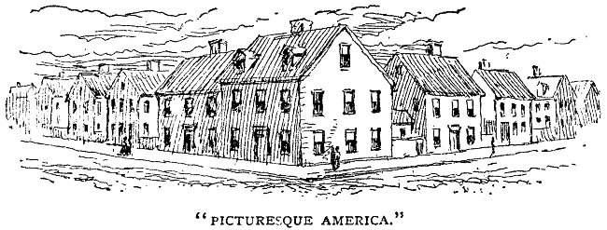
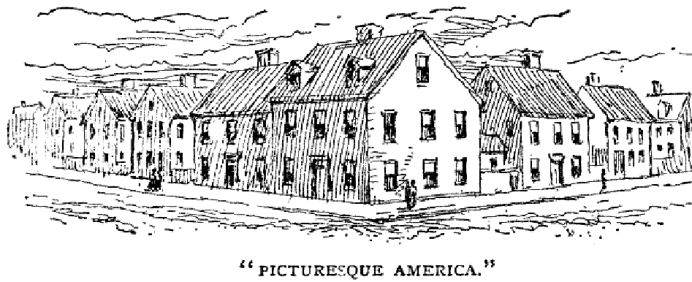
Thus Mr. Ruskin on the domestic architecture of England. What would that merciless
critic say, or rather what profundity of silence would he employ to express his opinion, of
ours? It will be well for him and for us if he holds to his resolve never to visit America.
This servile spirit of imitation, blind following of blind guides, is by no means confined
to the outsides of our houses; it not only penetrates the interiors, but more or less
influences all our affairs. Charge me with a professional interest if you will, I assure you
no man can, in justice to himself or the community, build a house for his own use just like
any other. He must attempt something better adapted to his needs and tastes than that can
be which precisely suits some one else. If he can give no better reason for building as he
builds, for furnishing as he furnishes, for living and thinking as he lives and thinks, than
that another has done so before him, he may serve for the shadow of a man, but will never
make the substance. Eastlake, another English authority, refers to continental cities and
villages "the first glimpse of which is associated with a sense of eye-pleasure which is
utterly absent in our provincial towns." And then, to drain the dregs of our humiliation,
we are asked by his American editor to believe that, nevertheless, certain towns of the
British Isles are miracles of picturesqueness "as compared with American towns, which
have nothing but a succession of tame, monotonously ugly, and utterly uninteresting
streets and squares to offer to the wearied eye." Yes, I am anxious about the outside of the
house, but do not for a moment forget that it should always be subordinate to the
weightier matters, the higher and holier uses of "home buildings."
Have I squared up your point? Let us return to the trowel.
The somewhat vexed question of mortar you shall answer according to your taste, so
far as to choose between dark gray—"black" it is commonly called—and some shade of
red, resembling the brick used. Between these two there seems to me to be one of those

questions of taste, concerning which we are not permitted to dispute. With the dark
mortar the joints will be visible, modifying the color of the wall, in some cases, perhaps,
improving it; while the red will give a more uniform tint, on which not only colored brick
or stone will appear to the best advantage, but the lines of the openings and other essential
details are brought out in clearer relief. You would perhaps expect coloring the mortar the
same shade as the brick to give precisely the effect of painting the entire wall. But it is not
so. As in wood or stone, though in less degree, there is a kind of natural grain, even in the
unnatural material, strengthened by oiling, but softer and richer than any painted surface.
There seems to be no evidence that the mortar is injured by proper coloring-material,—
mineral paints, or even lampblack, if you like it; I don't. Whether you like it or not, you
are
not
to use
white
mortar for the outside work. Unless, indeed, you propose to build of
pressed brick, in which case you will need it to show your neighbors how fearfully and
wonderfully nice you are. If you are so devoted to worldly vanity as to build in that
fashion in the country, I don't believe it will be possible for me to help you.
Chimneys deserve a chapter to themselves, they are so essential and so often abused.
Let them start from the cellar-bottom and run straight and smooth to the very outlet. If
you wish to be exceptionally careful and correct, use round pipe, cement or earthen,
enclosed by brick. When it is so well known how often destructive fires are caused by
defective flues, it is surprising that more care is not taken in building chimneys. They
should be intrusted to none but workmen who are conscientious as well as skilful,
otherwise every brick must be watched and every trowel full of mortar; for one defect
ruins the whole, and five minutes after the fault is committed it can never be detected till
revealed by the catastrophe.
If the spaces between the bricks were always filled with good mortar, it would be
better not to plaster the inside of the flues, as the mortar is liable to cleave from the brick,
and, hanging by one edge, form lodging-places for soot. As commonly built it is safer to
plaster them within and without, especially without, for that can be inspected. The style of
the visible part must depend upon the building. One thing lay up in the recesses of your
lofty mind: A chimney is most useful and honorable, and you are on no account to be
ashamed of it. Don't try to crowd it into some out-of-the-way corner, or lean it off to one
side to clear a cupola,—better burn up the cupola,—or perch it daintily on a slender ridge
like a brick marten-box; let it go up strong, straight, and solid, asserting its right to be,
wherever it is needed, comely and dignified, and finished with an honest stone cap. Ruins
are charming in the right place, but a tattered chimney-top on an otherwise well-preserved
house is vastly more shabby than picturesque.

A common objection to brick houses is their redness; but there is no law against
painting them, if their natural color is really inharmonious. Paint will improve the walls,
will last longer on good brickwork than on wood, and there is no deception about it,
unless you try to imitate stone. Still, it is not necessary, oil being just as good; and there is
a sort of solid comfort in knowing that your house will look just as well fifty years hence
as it does now, that it will mellow and ripen with age, and not need constant petting and
nursing to preserve its tidiness.
The model house to which I alluded in beginning this subject will be, in brief,
somewhat as follows: The outer walls will be vaulted, thoroughly non-conducting both of
heat and of moisture. All the partitions will be of brick, precisely adapted in size to their
use,—I am not sure but they will be hollow. The body of the floors will be of brick,
supported, if need be, by iron ties or girders, all exactly fitted to the dimensions of the
rooms, so that not a pound of material or an hour of labor shall be wasted on guess-work
or in experiments. From turret to foundation-stone, the house will be a living, breathing,
organic thing. If the weather prophet will declare what the average temperature of the
winter is to be, we can tell to a hodful how much coal will maintain a summer heat
throughout the establishment. You may be sure it will not be more than you now use in
keeping two rooms uncomfortably hot and in baking the family pies. There will be no
lathing, except occasionally on the ceilings; even this will not be necessary. You may
make a holocaust of the contents of any room in the house, and, if the doors, finish, etc.,
happen to be of iron, as they may be, no one in the house will suspect your bonfire, until
the heap of charcoal and ashes is found. Dampness and decay, unsavory odors and impure
air, chilly bedrooms and cold floors, will be unknown. The ears in the walls will be
stopped, there will be no settlement from shrinking timbers, no jelly-like trembling of the
whole fabric when the master puts his foot down. Finally, the dear old house will be just
as sound and just as lovely when the future John brings home his bride as when his
grandsire built it. And it won't cost a cent more than the weak, unstable things we're
raising by the thousand.
The coming house will surely be a brick one, but before it comes there will be plenty
of work for the carpenters, and I shall not be at all surprised if you finally decide to build
of wood.

LETTER XVI.
From Mrs. John.
DOMESTIC DISCIPLINE.

MR. ARCHITECT: Dear Sir,—Yesterday afternoon Sister Jane and I went out after
May-flowers. We didn't find any, but on our way home met the schoolmaster, a friend of
Jane's, who knew where they grew and offered himself as a guide. I was too tired to walk
any farther, so they went off without me. Coming into the house, I was taken all aback by
the sight of John lying on my best lounge, his muddy boots on his feet, his hat on the
floor, and your last letter crumpled savagely in his hand. I was vexed, thankful, and—
frightened.
I've taught the baby, who is only twenty-nine months old, to hang up his little cap, and
not to climb into the chairs with his shoes on, but I can't make a model husband of John.
He is as good as gold, but will leave his hat on the floor, his coat on the nearest chair, and
never keeps himself or any of his things in order in the house. He says it's born with him;
comes from a long line of ancestors (he's been reading Darwin lately) who lived in houses
without any cupboards or drawers or closets, and he could no more put away his hat and
coat when he comes in than a blue-jay could build a hang-bird's nest. Yes; I was vexed,
but thankful, too, that Jane was out of sight. Of all people in the world; she has the least
mercy for anything like domestic untidiness. I only hope she will some time have a house
and a husband of her own; if one doesn't shine and the other shake, her practice will fall a
long way behind her preaching. Let me warn you now, not to attempt making any plans
for her. It will be worry and vexation of spirit from first to last. Every knot will be
examined, every shingle ironed flat before it is laid, every nail counted and driven by rule.
When I tell her it would wear me out, body and mind, to feel obliged to keep things
always in order, she gravely reminds me that Mrs. Keep-clean lived ten years longer than
Mrs. Clean-up, besides having an easier time, a tidy house, and an enviable reputation all
her life. Yes; I was thankful she had gone philandering off after May-flowers, and hoped
she would stay till I had had time to brush up the room and get John into presentable
shape. But as soon as I went to rouse him I was thoroughly frightened. His face was
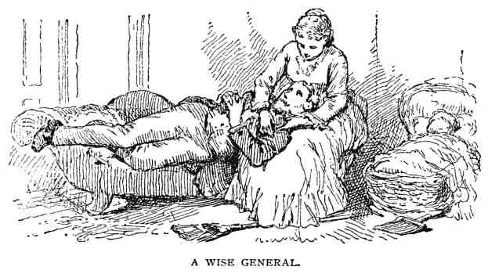
flushed, his hair was ruffled, and he looked up in such a dazed kind of way, I really
thought he was going to have something dreadful. He held out your letter and told me to
read the last sentence, which I did. Even then I didn't understand what was the trouble
until he went on to say that your final charge was too much for him. He was totally
discouraged. You began, he said, by urging him to build a stone house, which neither of
us liked, though we finally came around to it,—even went so far as to commence hauling
stones. All at once you went into ecstasies over brickwork, and argued for it as though our
hope of salvation lay in our living in a brick house. Now, as he was beginning to feel that
he must change his mind again (he would almost as soon change his head) and cultivate
an admiration for brickwork, you must needs switch off upon another track and coolly
advise him to build of wood! He declared he was further from a new house to-day than
three months ago. At that rate we should live in the old one till it tumbled down over our
heads, which I don't propose to do.
The baby was asleep, so I sat down on the lounge, took John's head in my lap, and
tried to explain what you meant. I told him I had heard enough about brick, and didn't
care what you said about wood. We should hold to our original plan and have a stone
house; but you didn't know where it was to be, and wished us to be thoroughly posted,
then use our common-sense and decide for ourselves what it should be. In some places it
would be most absurd to build of wood; in others equally so to build of anything else. The
matter of cost, too, might affect our choice, and that you knew nothing about.
In my efforts to restore his equanimity, I had forgotten my broom and dust-pan, lying

in the middle of the floor; forgotten John's big boots, not only on the lounge, but
directly on one of Jane's most exquisite tidies; forgotten—actually forgotten—the baby,
and was treating my disturbed husband in genuine ante-matrimonial style, when, of all
things to happen at this very crisis, in marched Sister Jane and her cavalier!
Simultaneously the baby awoke with a resounding scream.
Now there are three things that my notable sister holds in especial abhorrence,—untidy
housekeeping, sentimental demonstrations between married people, and crying babies;
and here they all were in an avalanche, overwhelming, not only herself, but a most
prepossessing young man, who, for all I knew, was viewing me with a critic's eye, as a
possible sister-in-law, and wondering how far certain traits are universal in families.
You will think I stand in great awe of Sister Jane; and so I do, for though she is two
years younger than I, unmarried, and, candidly, not a bit wiser, she is one of those
oracular persons who, unlike Mr. Toots, not only fancy that what they say and do is of the
utmost consequence, but contrive to make other people think so, too.
It is one of my husband's notions that nothing in the house is too good to be used every
day by those he loves best, meaning baby and I. So I have no parlor—no best room
always ready for exhibition—into which I could send them, but my inspiration came just
at the right moment.
"Don't, Jane, don't, for pity's sake, bring all that rubbish into the sitting-room!" She
had her hands full of moss and flowers. "Please take it out on the piazza. John will carry
you some chairs." And Jane was positively too much astonished to say a single word, but
turned and walked out the way she came in, driving her dutiful escort before her.
Fortunately, our piazza is eight or nine feet wide. I wouldn't have one less than that. So
John took out the chairs, and was properly presented to the young gentleman.
Half an hour later, when order once more prevailed, I went out to find Jane finishing a
lovely moss basket, and the gentlemen amiably building air-castles. John had been
reading your last letter aloud, omitting your reply to Jane's question, and was advocating
brick in a most edifying fashion. As I sat down, the young man inquired very seriously if
there would be any difficulty in making additions to a brick house, in case one wished to
begin in a small way. John gave one of his queer looks, and guessed not; I, for a wonder,
kept still; and Jane blushed brilliantly, remembering that she had already asked the same
question on her friend's account.
I am, truly, anxious about the kitchen and closets, whatever nonsense my husband may

write, but should be sorry to have the house look just like any other, and, of course,
wish to have it look well. Why may not our stone house be built in the manner of your
model brick one, at least basement and first story, thoroughly warmed and ventilated,
brick partitions, fire-proof, and so on,—that is, if we can afford it? And that brings me to
the question that I intended to ask in the beginning, Are these suggestions intended to
apply to common kind of buildings or only to those that are usually described as "first
class"? Architectural rules and the principles of good taste are not thought to concern
those who, in building, know no law but necessity,—with whom the problem is to get the
greatest amount of use for the least possible outlay.
John is industrious and serene, this morning. He thinks my letter isn't very practical,
and hopes you won't forget that the subject in hand is house-building, not family history.
Yours truly,
MRS. JOHN.

LETTER XVII.
From the Architect.
GOOD TASTE IS NOT A FOE BUT A FRIEND TO ECONOMY.

MRS. JOHN: Dear Madam,—For your wise and tender treatment of John you have my
heartiest thanks and admiration. It is not strictly an architectural suggestion, but could you
not found a sort of training-school for wives who have not learned to manage their
refractory husbands? I'm sure you would have plenty of pupils.
Your query as to applying these hints I am glad to answer. Instead of preventing its
indulgence, close economy demands the exercise of the most refined taste. The very
houses that must pay strict regard to the first principles of art are those upon which not
one dollar can be wasted. But these fundamental rules are identical, whether the building

costs five hundred dollars or fifty thousand. When the newspapers describe "first-
class" houses, those above a certain size or cost are meant. Let us henceforth have a truer
standard, placing only those in the front rank whose design and construction are
throughout in wise accord with the material of which they are built and the uses for which
they are intended.
Notwithstanding your want of interest in the wood question, I must give your husband
one chapter on that subject, and promise him it shall be thoroughly practical, free from all
romance and family allusions.

LETTER XVIII.
From John.
OUR PICTURESQUE ANCESTORS.

MY DEAR ARCHITECT: I've no doubt it would be vastly agreeable to you to have
Mrs. John keep up this end of the correspondence. Very gratifying, too, to another
party,—the paper-makers. It would be a big thing for them. But I don't want to hire a
housekeeper, even in so good a cause, not till I have a house.
In spite of Mrs. John's devotion to her first love (I mean the stone walls), it is, as you
say, quite possible that our family mansion will be wood; and Barkis is willin' to hear
what you have to say about it.
One topic in your reply to my wife's historical report I hope you will work up more
fully. Just explain, if you can, why the cheap buildings we have nowadays are so much
less satisfactory to look at than those built fifty or a hundred years ago. Do you suppose
the bravest artist that ever swung a brush would dare put an ordinary two-story house of
modern style on the front seat in a New England landscape? It would ruin his reputation if
he did,—even without the French roof. Can you tell why? There's no such objection to the

homesteads of a generation or two ago. Don't tell me age is venerable, and moralize
about the sacred associations and old-time memories that lend a halo of poetry and
romance and what-'s-his-name to these relics of the past. That's all very well in its place,
but if our grandchildren can discover anything artistic or even picturesque in our common
houses of to-day, they'll be a progeny of enormous imaginations,—regular Don Quixotes;
windmills will be nothing to them.
Yours,
JOHN.

LETTER XIX.
From the Architect.
THE USE AND THE ABUSE OF WOOD.

DEAR JOHN: One reason, among many, why the old-time houses are more grateful to
the eye than those of similar cost but modern style, is that they were built of wood
honestly and legitimately used, when wood was on all accounts the most suitable material
for building. It is so still, and will be for a long time in many places, for its economy and
convenience. Given a fair chance, it may be made very durable, and is even rendered
practically fire-proof without great cost, by kyanizing and various other methods that are
adopted for the same purpose. You will find one mode described in the June number of
Harper's Magazine for 1870. Wood is effective, too, in appearance, when rightly used,
which, more's the pity, does not often happen; for of all the materials that minister to
human comfort and needs, this seems to me the most abused. Iron, like the old-time
saints, betrays not its solid worth till it has been tried by fire,—is all the better for being
hammered and beaten; stone is as much improved as an unruly boy by a good dressing;
while bricks, like ghosts, come forth from their purgatory for the express purpose of being
laid. All of these, by appropriate treatment, are invested with graces and glories that by
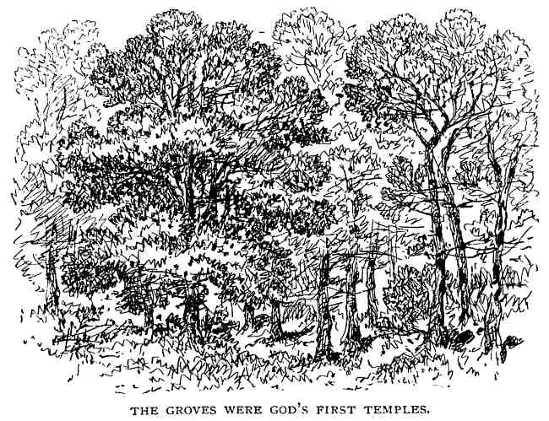
nature they never owned. But a tree, graceful, noble, and grand beyond all human
imitation, is ignominiously hewn down, every natural beauty disguised or annihilated, and
its helpless form compelled to assume most uncouth shapes and grimmest colors.
Of late our injustice is greater and more disastrous; for we are destroying the very
sources of supply without providing for the future, using wood in large quantities where
other materials would be better and cheaper. Yet we think ourselves very economical.
Once it was common to enclose wood buildings of all grades by walls at least ten or
twelve inches thick, sometimes much more, and solid at that. They were called log-
houses. Now it is the fashion to use two by four inch studs standing in rows at such
distances that the whole substance of the frame in a single sheet would be about half an
inch thick. These are suggestively called balloon frames. The former would be huge and
inconvenient, the latter are often fair and frail. That the frame of the outer wall of a
wooden building should be mainly vertical is evident, the outer studs, if possible,
extending from the sill to the plates, and as many of the inner ones as may be reaching
through both stories, especially those by the staircase, where the shrinking of the second-

floor timbers will reveal ugly cracks and crooks. That the greatest strength and
economy of material are secured by sawing logs into thin, wide scantling is also beyond
question, but don't try to save too closely on a bill of timber. A thousand feet added to the
width of the studs and the depth of the joist will make the difference between a stiff,
unterrified frame, and a weak, trembling one. Neither be sparing of the number of these
light sticks. Sixteen inches between centres is far enough for studs or joists; twelve is
better, though particulars will depend on circumstances. We have no use for the old-
fashioned huge square posts, horizontal girts, and braces midway the walls of a two-story
building, having found that studs two inches by five will carry all that is required of them
as well as if ten times as large. Let us generously give the light frame the stanch support
of a sound, well-matched, and bountifully nailed covering of inch boards. There's great
virtue in tenpenny nails. Let the building be well peppered with them. Even after
boarding, your walls will have less than two inches of solid wood. If you wish to make an
example of yourself, lay this boarding diagonally; and, to cap the climax of scientific
thoroughness, having given it a good nailing and a layer of sheathing-felt, cover the
whole with another wooden garment of the same style as the first, and crossing it at right
angles. All of this before the final overcoat of clapboards, or whatever it may be. A house
built in this way would laugh at earthquakes and tornadoes. It couldn't fall down, but
would blow over and roll down hill without doing any damage except disarranging the
furniture, and, possibly, shaking off the chimney-tops! It would hardly need any studs
except as furrings for lath and plastering, and would be very warm. You know my mind
about floors. If you can't afford joists stiff enough to hold you without jarring, even when
you chance to cut a caper with the baby, defer building till you are a little richer. Floors
need the well-nailed linings, too, especially those of the upper stories, almost as much as
the outer walls, and should be deafened with mortar if you can stand the cost; if not, with
felt. The upper floors we will talk over by and by. Some people have a fancy for filling in
between studs with soft brick, but I don't believe in it. It is seldom well done, it injures the
frame, and costs more than back plastering, without being much if any better. Rather
build a brick house outright. It is well, however, to lay a course or two of brick in mortar
against each floor, filling the space between the inner base board and the outer covering
entirely full and solid, leaving never the faintest hint of the beginning of a chance for
mice. Then when you hear the dear little creatures galloping over the ceiling, driving
hickory-nuts before them and making noise enough for a whole battalion of wharf rats,
there will be a melancholy satisfaction in knowing that you did your best to keep them
out, and these brick courses will make the house warmer by preventing currents of air.
Here is one advantage in wood not easily obtained in brick or stone,—the overhanging
of the whole, or a part of the second story, which may be made picturesque in effect and

will add much to the charm of the interior. It may be simply an oriel window swinging
forward to catch the sun or a distant view, an entire gable pushing the guest-chamber
hospitably forth, or the whole upper story may extend beyond the lower walls, giving
large chambers, abundant closets, and cosey window-seats. Of course, such projections
must be well sustained. Let their support be apparent, in the shape of massive brackets or
the actual timbers of the house.
Speaking of brackets, if we could learn to think of them, wherever they occur, simply
as braces, we might have better success in their treatment. Our abominable achievements
in this line spring from an attempt to hide the use of the thing in its abstract beauty. The
straight three by four inch braces found under any barn-shed roof are positively more
agreeable to look at than the majority of the distorted, turned, and becarved blocks of
strange device that hang in gorgeous array upon thousands of "ornamental" houses.
Besides these there are a host of pet performances of builders and would-be architects that
deserve only to be abolished and exterminated; put up, as they are, with an enormous
waste of pine and painful toil of the flesh, to become a lasting weariness to the spirit. Far
more satisfying and truly ornamental is it, to let the essential structure of the building be
its own interpreter. Very much can be done by a skilful arrangement of the outer covering
alone. Don't try to clothe the house with a smooth coat of boards laid horizontally with no
visible joints or corner finish. Such a covering is costly, defective, and contrary to first
principles. Clapboards are good. Hardly anything is better, but don't feel restricted to one
mode. I send you some sketches suggesting what may be done in this department by a
careful design in the use of wide boards and narrow boards, clapboards and battens;
boards horizontal, vertical, and cornerwise,—any and all are legitimate, and it may be
well to use them all on one building.
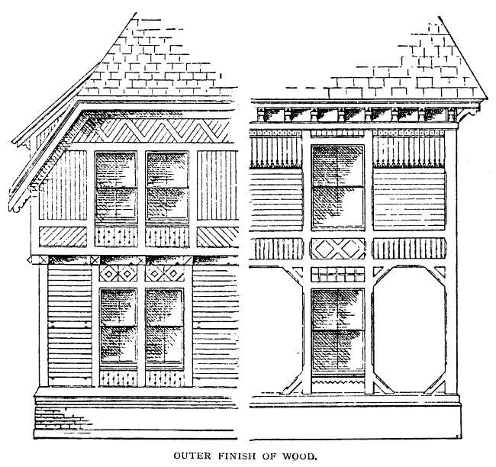
Many points relating to the use of wood and appertaining equally to buildings whose
walls are of brick or stone, we may find farther on. In closing, let me adjure you by all
your hope of a comfortable, safe, and satisfying house,—by all the common-sense in your
possession and all the capital at your command,—resolve that you will never—no,
never—build your house of unseasoned timber.

LETTER XX.
From John.
A SURRENDER AND CHANGE OF BASE.

MY DEAR ARCHITECT: It was very well for Noah and the other antediluvians, who
had any little building to do, to wait for their timber to season. When a man has a
thousand years or so to live, he can afford to take things easy. It's different in this great
and glorious nineteenth century, when the chief aim is to make the shortest time on
record. You know our Western farmers have a brisk way of going out into their thousand-
acre wheatfields before breakfast, reaping, threshing, and grinding the grain, which their
thrifty wives make into biscuit for the morning meal; and you've heard of the young man
who caught a sheep in the morning, sheared it, carded, spun, and wove the wool, cut the
cloth and made the coat to wear at his own wedding in the evening. Young America don't
understand why a pine or an oak tree can't be put over the course, like a sheep or an acre
of grain. Besides, you talk like an old fogy. When a man says he has decided to build a
house, he means he is ready to begin,—right off; and if our lumber-dealers won't keep dry
stuff (which of course they won't unless obliged to), then he must use green.
I'm surprised you don't admire the fanciful brackets and other wooden straddle-bugs
people are so fond of decorating their houses with. By the way, if these brackets are
purely ornamental, there ought not to be two alike, any more than you'd have two busts or
two pictures alike in one room. Suppose you collect an assortment of the rich and rarest
specimens, and hang them, like Lord Dundreary's shirts, "all in a wo," on somebody's
villa. Wouldn't they be lovely? I'd like to pursue the subject, but have other fish to fry.
Mrs. John is right, as usual; our house will be a stone one, and will not be built until
next year. Meantime, the timber will have a chance to season, and we shall have time to
study up our plan and sort of get the hang of it.
Now I want you to transfer your interest to another case. Who should drop down upon
us, last week, but our old friend Fred? Been out West for the last dozen years or more;
enterprising and prosperous, you'll be glad to hear. Come home to stay, bringing a wife
who is sure to make Mrs. John jealous, a triplet of boys (the oldest half as big as his dad),

and plenty of stamps. He has bought the Captain Adams place, and is going to move
off the old gambrel-roofed house (has a dozen or two men at work already) and build a
brick one in place of it. I've given him the benefit of your advice in my behalf, and now
he invites me, in Western fashion, to stand aside and give him a chance,—which I'm very
willing to do, for he's a tiptop fellow and so is Mrs. Fred. Eastern people Westernized,—if
you can find a better sort of neighbors I'd like an introduction!
Yours,
JOHN.

LETTER XXI.
From the Architect.
HOSPITALITY AND SUNLIGHT.

DEAR JOHN: Our old friend shall not be neglected. He has only to present his case
and make known his wishes. Meantime, in arranging your own plans, be generous if you
can; not lavish or extravagant in expenditure, but generous in feeling and expression. Let
your doors and windows be wide, and your roof be high. A wide door is far more
convenient than a narrow one, usually much better in appearance; and for the windows,—
when shall we learn the unspeakable worth of the bountiful light of heaven? Does Mrs.
John complain that the sunlight will fade her carpets? Let them fade, and know of a truth
that all the colors of all the carpets of all the looms that ever throbbed are not worth to the
civilized mortals who tread the dust-containing fabrics one single hour of unobstructed
sunshine. Is it that our deeds are evil, that we seem to love darkness rather than light; or is
it through our ignorant exclusion of this glorious gift, "offspring of heaven first born,"
that we are left to wander in so many darksome ways? Be generous, did I say? rather try
to be just to yourself. Practically, the larger opening is scarcely more expensive than the
small one. The work of construction is no greater, and the material for the door or
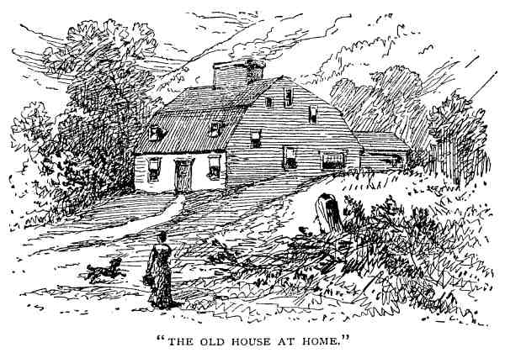
window costs but little more than the thicker wall of wood, brick, or stone.

I remember an old farm-house on the side of one of our rocky New England hills, a
type of a fashion almost extinct, broad and brooding, low in the walls, small windows and
far between, high roof, wide gables, pierced by windows of various sizes, and queerly
located, as if the huge garret were inhabited by a mixed company of dwarfs and giants,
each with his own particular window suited to his height; in the centre a massive chimney
like the base of a tower, out of which the smoke rolled in lazy curves. At the east side of
the house, under the narrow eaves, and opening, I think, into the long kitchen, was one
huge window, as high as the others, and as wide as it was high. How it found a place there
I never knew, but nothing could be more benign in effect than its generous breadth. The
panes were small and green and warped, after the manner of glass known to former times;
but through it the sun poured a flood of warm light every morning, and on winter
evenings the glow of the firelight within made a grand illumination far across the snowy
hillsides; yet I don't think the old window was ever truly appreciated. The others seemed
to despise it, and try to keep at a distance in their narrowness and regularity. The little
square loopholes in the gables lifted their diminutive eyebrows in contempt; even the
green door looked blank and scowling, as though at a possible rival. I fancy the
housekeeper fretted at the larger curtain covering this wide, unwinking eye, and the extra
labor required on cleaning-days. But this one great square window was the sole

redeeming feature beneath the roof of the ancient farm-house. Beneath the roof, I say.
The roof itself was, and is, and ever shall be the great charm of those antiquated
houses,—not of the old alone, but if any new house shall ever rise, if you succeed in
building your own so that it shall seem to be the abiding-place of the incarnate genius of
domestic happiness, the roof of your earthly paradise will be bold and high. Pierced by
windows it may be, and broken by gables, but steep enough to shed rain and snow, and
high enough to be plainly visible to the coming guest, promising safety and welcome
beneath its tranquil shade. Practically, the steep roof is better than any other, because a
flat one cannot be as permanently covered with any known material at so little cost, the
multitudes of cheap and durable patent roofings to the contrary notwithstanding. By steep
roofs I mean any that have sufficient pitch to allow the use of slate or shingle. Such need
not be intricate or difficult of construction to look well, but must be honest and useful.
They can be neither unless visible, and here we see the holy alliance of use and beauty;
for the character and expression of a building depend almost wholly upon the roof. You
will lose, too, under the flat roof, the roomy garret of the old high-roofed houses. These
have for me a wonderful fascination. Whether the rain upon the shingles, the mingled
fragrance of seeds and drying herbs, the surprising bigness of the chimney, the mysteries
hidden in the worm-eaten chests, the almost saintly charm of the long-unused spinning-
wheels, crumbling mementos of the patient industry of former generations, or the shine of
the stars through the chinks in the shrunken boards, the old garret and all its associations
are among
the "long,
long
thoughts."
I
sometimes doubt
whether
the modern
conveniences we are so fond of proclaiming are really an equivalent to the rising
generation for this happiest of playrooms, this storehouse of heirlooms, this silent but
potent tie, that binds us to the life, the labor, and the love of the past.
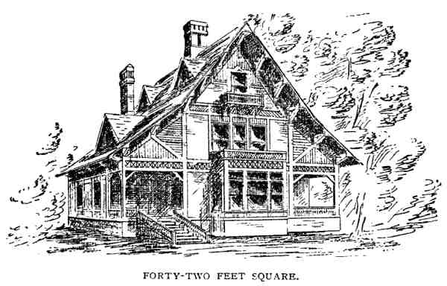

Let there be light, too, in this upper story. Spinning spiders and stinging wasps are not
half so terrible to the children who will make a half-way paradise of the garret as the
darkness that is covered by an unlighted roof.
If you have been living in cottage-chambers,—rooms in which a full-sized man can
hardly stand erect in the centre, and a well-grown baby scarcely creep at the sides,
unventilated, heated beyond endurance during the hot summer days, and retaining their
heat through the long, wakeful nights,—rooms in which the furniture must stand at
various distances from the walls as if marshalled for the house-cleaning battle, but in
which even the making of beds is a work of supreme difficulty,—if you've been living in
such rooms as these, I don't wonder, whatever architects or other men may say, that Mrs.
John objects, and insists on good, square chambers. But good, square chambers no more
require flat roofs than good, square common-sense requires a flat head. I don't believe
you will contrive a house, of whatever form or size, that may not be covered more
cheaply, more securely, and more tastefully by a steep roof than by a flat one. Of course,
I'm supposing your house to be isolated. Buildings in crowded streets or in blocks require,
on all accounts, entirely different treatment. By all means, then, have wide doors,
generous windows, and high roofs; and if you must build with strict economy you may be
morally certain that your house, though not perhaps as altogether lovely as you might
wish, will still be cheerful and homelike.

Allow me to add, that, while faithfully striving to build a house that shall be honest
and cheerful, you will surely find yourself growing in the same direction.

LETTER XXII.
From Fred.
UNPROFESSIONAL SAGACITY.

DEAR ARCHITECT: Our mutual friend John recommends me to ask your advice in
regard to plans for my new house. Possibly you may help me, although the floor plans
sent herewith are about right; rooms enough and of the right size, the principal ones
adapted to the usual widths of carpeting. I am willing to expend something for the outside
appearance,—in fact, intend to have the best looking house in town,—but think it would
be foolish to build more rooms or larger than I want, much more so to dispense with
needed room in order to get a certain proportion of parts. I merely mention this because,
with all due respect, I am doubtless the best judge of my own wants, and don't care to
have the dimensions of the building changed. The relative location of the different
apartments is also satisfactory, except perhaps some slight deficiencies in the rear portion,
which I left incomplete for want of time. As to exterior, would like a French roof and
tower, with fashionable style of finish throughout.
Shall commence laying foundation next week, and you will please consider yourself
invited to eat turkey with us in the new house next Thanksgiving.
Truly,
FRED.

LETTER XXIII.
From the Architect.
STAIRWAYS AND OUTLOOKS.

Dear Fred: Your plans are before me, also your letter; also the proverbs of Solomon,
from which I read, in order to fortify myself for the work before me, sundry suggestions
concerning the duty of faithful friends,—the undaunted, disagreeable sort who cry aloud
and spare not. It's quite right for you to try to show what you would like, quite true that
you ought to know your own needs and tastes better than any one else, and though I
cannot agree with you, I'm glad you have a mind of your own; those who have not are of
all men most miserable to deal with, most difficult to suit. Indeed, when a man feels
clearly a lack in his own home-life which nothing but a new house will supply, he is sure
to have some decided notions as to what that house shall be. But when you assure me in
good set terms that this plan is your beau-ideal, I must ask, also with profound respect, if
you know what you are talking about. Put in your foundation, by all means, but remember
how much easier it is to change a few lines on paper than to remove a stone wall. It is not
a pleasant job to cut a door into a finished and furnished room, or even to change the
hanging of it. This house, if I understand aright, you intend for a permanent home. How
immeasurably better to spend six months, if need be, in perfecting the plans, than by and
by to be tormented with defects that can only be removed by great expense and trouble!
It's a grand thing to go ahead, provided you are right; the more "go," the worse, if you
happen to be on the wrong track. Candidly, your plan hardly deserves to be called a
beginning. The arrangement of the rear part, which you chiefly omit, is, in fact, the most
difficult and important of the whole. But I've promised Sister Jane a chapter on kitchens,
of which, when the time comes, you can have the benefit. Meanwhile, complete the
unfinished part of your plan,—it only requires you to spend a few brief moments,—and I
will venture some suggestions on this which lies before me.

The front stairs as laid down would reach just half-way to the second floor,—a
peculiarity of amateur sketches so universal that we will say nothing more about it. But
what principle of good taste or hospitality requires you to blockade the main entrance to
your house with this same staircase? Do you send all your visitors, of whatever name or
nation, direct to the upper regions the moment they enter? Why, then, make the northwest
passage thither the most conspicuous route from the door? Do you intend to restrict the
family to the back stairs, which by your showing are, like the famous
descensus Averno
,
wonderfully easy to go down, but mighty hard to get up again? Yet you place these front
stairs at the very farthest remove from the rooms most constantly used in both stories.
Perhaps you propose to announce "apartments to let" on the second and third floors. No?
What reason, then, for imitating hotels, lodging-houses, double-barrelled tenements, and
other public and semi-public buildings from which a short cut to the street is essential?
Don't tell me you wish them to be ornamental as well as useful. I know that; but
remember the stairs are built for the house, not the house for the stairs. You had better
lose them wholly as an ornamental feature, than destroy the charm of what should be the
most prepossessing portion of the interior. Moreover, they can have no pleasure-giving
beauty if manifestly out of place,—a safe rule for general application. Build them where
they will be most useful, that is, as near the centre of the house as possible; make them
grand and gorgeous as the steps to an Oriental palace,—so broad and easy of ascent that
the upward and onward way will be as tempting as were the Alps to Mr. Longfellow's
aspiring youth. But keep them away from the front door,—out of the principal hall, which
should be open, airy, and free, suggesting something besides an everlasting getting up
stairs. If the staircase hall cannot be arranged at right angles to the main hall, an arch or
ornamental screen may be introduced, partially separating the two and giving character to
both.
Have you been living in a city of late? It must be, else why so complacent with a
narrow hall, steep, obtrusive stairs, and, O, why, tell me why, do you not fix the location
of your windows with some regard to views, not only out of the house but through it. I
remember one country dwelling built by a retired civilian in the inevitable city style;
windows at the end giving a narrow view of the road in front, while the entire side walls
were absolutely blank and bare, never so much as a knot-hole through which the
occupants could get a glimpse of the field and forest that stretched broadly away at either
side. I've no doubt the owner hung oil-paintings on his parlor walls, and thought them
more lovely than all out-doors,—especially when he remembered their cost. The old
Roman who declared his soldiers made a bigger racket with their arms than Jupiter with
his thunderbolts, was modest beyond comparison with such a man. Your arrangement is
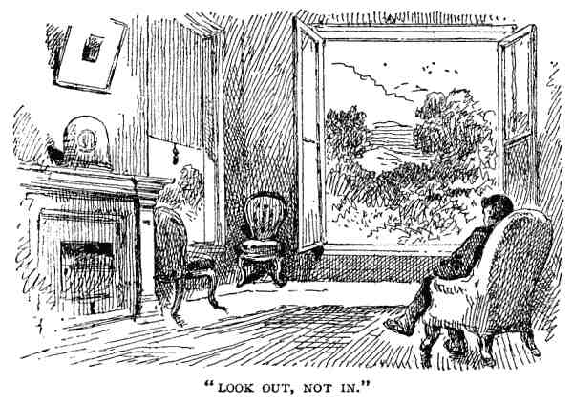
not quite so bad as that of the aforesaid civilian, but, like hosts of others, you fail to
make the most of your opportunities. Suppose you were able to secure for a small sum a
landscape painted by one of the masters and esteemed of great value. You would think it
folly to let the chance pass unimproved. By simply cutting a hole in the wall you may
have a picture infinitely grander than human artist ever painted; grander in its teaching, in
its actual beauty, its variety, and its permanency; grander in everything except its market
value. I am not sure but your children's children will find some one window in the old
homestead that commands a view of the everlasting hills, an heirloom even of greater
pecuniary value than the rarest work of art. Do not forget, either, the views
through
the
house. If your windows can be placed so that throwing open the doors from room to room
or across the hall will reveal a charming prospect in opposite directions, there's a sense of
being in the midst of an all-surrounding beauty, hardly possible when you seem to look
upon it from one side only. You have surely been abiding in a city. The interior of your
house is all that concerns you or your family. The outside—French roof and fashionable
finish, forsooth!—is for the public to admire. They are not to have any intimation what
sort of a home is sheltered by your monstrous Mansard; and it never occurs to you that
there can be anything out of doors worth building your house to see.

Here is another unhappy result of evil examples,—the sliding-doors between the two

parlors,
as
you
call
them,—an
arrangement
convenient
enough,
sometimes
indispensable in houses built on crowded streets, houses that only breathe the dusty air
and catch the struggling sunbeams at their narrow and remote extremities,—air and
sunlight at nobody knows how many hundred dollars the front foot. They are worse than
useless in such a house as yours.
I say your plan is scarcely a beginning; the same of this letter. But it's enough for once.

LETTER XXIV.
From Fred.
IN A MULTITUDE OF COUNSELLORS IS SAFETY.

MY DEAR ARCHITECT: Your criticisms are not wholly without reason. I can only
plead haste and inexperience.
Have been studying arrangement of rear part, and seem to get farther and farther from
a satisfactory result. The kitchen and dining-room must be convenient to each other, but
not adjacent; the pantries and larder easy to get at; back stairs accessible from all parts of
the house, and side entrance worked in somehow; washbowl and water-closet not far off,
but out of sight, and the whole department quite isolated from front hall. My wife can't
think of pantry and store-rooms at the south side, nor do we want kitchen or outer door at
the north. John's sister-in-law, Miss Jane, who appears to have some sensible notions,
thinks a kitchen should always have windows on opposite sides for light and ventilation.
John says I should have a kitchen large enough for wash-trays and a set kettle, but one of
my neighbors, who has just built a house, advises a laundry in the cellar. Altogether it 's a
troublesome problem, and, frankly, I give it up.
Do you really expect us to dispense with sliding-doors between the parlors? I'm sure
that won't pass. We would almost as soon give up the bay-windows,—everybody has

them nowadays.
Truly,
Fred.

LETTER XXV.
From the Architect.
DOORS AND SLIDING-DOORS, WINDOWS AND BAY-WINDOWS.
DEAR FRED: "Everybody has them!" What a monstrous load of iniquity and
nonsense that scape-goat has to carry! Everybody wears tight boots and bustles and
chignons and stove-pipe hats. Everybody smokes and brags, and cheats in trade, not to
mention a host of other abominations that can give only this excuse for their being: they
are common to a few millions of people who have not learned to declare a reason for the
faith that is in them or the works that grow out of them.
Let us take time to consider this sliding-door question,—folding-doors they used to be,
and, truly, I'm not sure that the rollers are any improvement on the hinges,—there is
something dreadfully barny about sliding-doors. Why do you want either? You have one
room which you call the parlor, supposed to be the best in the house, as to its location, its
finish, its furniture, and its use. Three of its walls are handsomely frescoed, curtained, and
decorated with pictures or other ornaments; the fourth is one huge barricade of panel-
work. When the two parts are closed you have a constant fancy of rheumatic currents
stealing through the cracks, and an ever-present fear lest they should suddenly fly open
with "impetuous recoil, grating harsh thunder" on their wheels, and not exactly letting
Satan in, but everything in the room fall out; an idle fear, for they can only be shoved
asunder by dint of much pushing and pulling, especially if they are warped by having one
side exposed to more heat than the other, as usually happens. Being at last opened by
hook or crook, another room is revealed, commonly smaller, more shabby in appearance,
a sort of poor-relation attachment, spoiling the completeness and artistic unity of the

larger one. By care you may avoid something of this; if you follow the fashion, you
will have the most of it. When the two rooms are twins, alike in every respect, they are
really one large room, fitted up, for economical reasons, with a movable screen in the
centre, by means of which you may warm (excepting rheumatic currents as above) and
use one half at a time. But call things by their right names. Don't talk grandly about your
two parlors when you mean two halves of one. Have wide doors, by all means, not only
between rooms but into main hall,—four, six, or eight feet, if the rooms are so wide and
high that they shall not be disproportionately large. Then, if you must have the whole
broadside of sliding or folding doors, let the two rooms thus connected be of different
styles but equal richness,—different, that they shall not seem one room cut in two,—
peers, that one shall not shame and cheapen the other.
Doors are a great bother, at best. I wish they could be abolished. They are always
slamming, punching holes in the plastering with their knobs, creaking on their hinges,
bruising the piano, pinching babies' fingers, and making old folks see stars when they get
up in the night to look for burglars. Heavy curtains are infinitely more graceful, equally
warm, and not half so stubbornly unmanageable. Then think of entering a room. By her
steps the goddess is revealed; but who can walk like a goddess while forcing an entrance
between two sliding-doors, maybe wedging fast half-way through? How different from
passing in quiet dignity beneath the rich folds of overhanging drapery! But I suppose we
must leave all that to the Orientals, at present.
"You would almost as soon give up the bay-windows!" Well, you might e'en do worse
than that. Now let your indignation boil. Bay-windows are very charming things
sometimes; sometimes they are nuisances. Some have been so appropriate and altogether
lovely that any pepper box contrivance thrusting itself out from the main walls and
looking three ways for Sunday is supposed to be a bower of beauty, a perfect pharos of
observation, an abundant recompense for unmitigated ugliness and inconvenience in the
rest of the building. Truly, a well-ordered bay-window will often change a gloomy,
graceless room into a cheerful and artistic one, but large, simple windows are sometimes
rather to be chosen than too much bay. In many, perhaps the majority, of cases, it is wiser
to extend the whole wall of the room in the form of a half-hexagon or three sides of an
octagon, costing no more, and repaying the cost far more abundantly.
While on the subject let us finish it. If you indulge in a regular bay-window, make it
large enough to be of real use; don't feel constrained to build it with more than fifteen
sides; remember that two stories will not cost twice as much as one, while the second is
pretty certain to be the pleasanter; don't carry the ceiling of the main room level and

unbroken into the bay, or, because a certain one you may have seen looks well in its
place, resolve to have another just like it, regardless of its surroundings. I sometimes
fancy there must be a factory where bay-windows are made for the wholesale trade, all of
one style, strictly orthodox, five-sided, bracketed, blinded, painted with striped paint, and
ready to barnacle on wherever required. In the stereotyped pattern the blinds are apt to be
troublesome. If outside, they clash against each other and refuse to be fastened open;
while inside they are a mighty maze of folds, flaps, brass buts, and rolling slats. In the
first case, wide piers between the sash are necessary; in the second, boxings for the
blinds. Both require ample room, which, fortunately, you have. Sixthly, and in
conclusion, there is no one feature which may be more charming, combining so much of
comfort and beauty, as windows of this class, from the simple opening, pushed forward a
few inches beyond the wall face, to the broad extension of the entire room; but there be
bays and bays.
Speaking of blinds,—what shall be done with the other windows? You will protest
against concealing your elegant, single panes of plate-glass by outside blinds,—it won't
answer to hide your light under a bushel in that way,—and yet while there is no complete
finish without well-arranged inside shutters, they alone are sadly inefficient in rooms with
a southern exposure, where light and air are needed. They may be fitted with boxings,
into which they are folded, or arranged to slide into the wall. I like the old-fashioned
boxing, window-seat and all, also the ancient close-panelled shutters. True they make a
room pitch-dark when closed, and it is doubtless wisest to have some of their central folds
made with movable slats, but they give a charming sense of security and seclusion when
the wintry blasts roar around our castle. On the other hand, the light outside blinds, that
shake and rattle and bang when the stormy winds "do blow, do blow," are a fair substitute
for the cooling shade of forest-trees. You may have learned that life is a succession of
compromises. Building in New England certainly is. No sooner do we get nicely fortified
with furnaces, storm-porches, double windows, and forty tons of anthracite, than June
bursts upon us with ninety degrees in the shade. Then how we despise our contrivances
for keeping warm, and bless the ice-man! We wish the house was all piazza, and if it were
not for burglars and mosquitoes, would abjure walls and roof and live in the open air. Just
here is our dilemma. We go "from Greenland's icy mountains to India's coral strands" and
back again every twelve months, whether we will or no, and are obliged to live in the
same house through it all. It's really a desperate matter. I've been to the ant and the beasts
and the birds. They recommend hibernating or migration, but our wings are too short for
the one, our fur too thin for the other!
Seriously, you must not forget to prepare for extremes of climate. Fortunately the

walls that most thoroughly resist the cold are effective against the heat. The doors and
windows—the living, breathing, seeing, working part of the house—demand the twofold
provision. You must have double windows in winter, to be taken off (laid away and more
or less smashed up) in summer; outside blinds to ward off the summer sun, which may, in
their turn, be removed when we are only too glad to welcome all the sunshine there is.
The vestibules—portable storm-porches are not to be tolerated—must also be skilful
doorkeepers, proof against hostile storms, but freely admitting the wandering zephyrs.
Piazzas are not so easily managed. We like them broad and endless in July and August,
but the shadows they cast we would fain remove when the very trees fold away their
sunshades. Often a platform, terrace, balcony,—whatever you please to call it, practically
a piazza without a roof,—is the best thing to have, for this will not keep the sun from the
windows, when comfort requires it may be shaded by a movable awning, and by its sunny
cheerfulness it will lengthen our out-door enjoyment two or three months in the year.
You are still floundering helplessly in the kitchen. I've no doubt Sister Jane has
excellent ideas on the subject,—probably knows ten times as much about it as you do.
Why not ask her to arrange matters for you?

LETTER XXVI.
From Fred.
EXPERIENCE KEEPS A DEAR SCHOOL.

MY DEAR ARCHITECT: We will let the sliding-doors slide, but hold on to the bay-
windows. I've acted upon your suggestion, and called on Miss Jane to help me through
the kitchen. She is studying the matter and will report to you soon. Meantime, will you
give directions about other inside work? I want it to be ornamental and modern in style.
Shall finish mostly in hard wood,—oak, walnut, or chestnut, perhaps mahogany and
maple. Please give me your opinion on that point. What do you think of graining where

hard wood is not used? Shall probably carpet throughout, and hope you will not
change dimensions of rooms to spoil the fit of them. What about wainscoting halls or any
of the rooms? Suppose common floors will answer, and common plastering for the walls,
if I paper; but shall I,—or do you recommend frescoing; and what do you say to cornices
and other stucco-work?
I've no time to go over all the points in your last. Some of them seem well put, others a
little wild. But I give them a fair hearing and suppose you won't insist upon my adopting
them. Am beginning to think I've a good deal to learn, and ought, I suppose, to be well
satisfied to learn, in some other school than that of experience.
Truly,
FRED.

LETTER XXVII.
From the Architect.
FASHION AND ORNAMENT, HARD WOOD AND PAINT.

DEAR FRED: The tone of your last, just received, is hopeful. Conviction of ignorance
is the only foundation on which Wisdom, or any other man, ever builded a house. But it
must be a genuine agony, as I'm sure it is in your case; so you are forgiven for asking
more questions in half a dozen lines than I can answer fully in a score of pages. Instead of
taking them up separately, I might give you a chapter of first principles, hoping you
would then need no special directions; but I find the value of most general observations
lies, like Bunsby's, in the application of 'em. It's not enough to say, "Be honest and
upright." Each particular falsehood and folly must be summoned, tried, and condemned.
You ask for a style of finish that must be ornamental and modern. But I don't
understand your meaning; shall need more definite instruction. Is your house intended for

ornamental purposes, as summer-houses, dove-cots, bird-cages, and the like, often are?
Is it to be a museum, art-gallery, or memorial hall? Diamonds and pearls are commonly
thought ornamental to those who can afford them; from pink plaster images and china
vases to bronze dragons and Florentine mosaics, there is an endless variety of ornaments
for domestic apartments. I've heard of a woman who was an ornament to her husband,
and of a man who ornamented a whole town; but when you ask me to furnish you an
ornamental style of finishing your house, I'm obliged to ask for particulars. You may have
curious carvings in the woodwork about the doors and windows and on the base-boards;
paint pictures, or set bright-colored tile, grotesque and classic, on the flat surfaces; cut a
row of "scallops and points" around the edge of the casings in imitation of clam-shells, as
I have sometimes seen; or you may build over your doors and windows enormous
Grecian cornices supported by huge carved consoles,—regular shelves, too high for any
earthly use except to remind you, by their vast store of dust, of your mortal origin and
destiny. I hold it to be the duty of the amiable architect to carry out the wishes of his
employer as far as consistent with his own peace of mind; and if you insist on having a
row of brass buttons around all your casings, and setting your own tin-type, life-size, at
every corner, I shall acquiesce; but my sober advice is that the interior work be simple
and unobtrusive. The most perfect style in dress or manner is that which attracts the least
attention; so the essential finish should not, by its elaborate design, challenge notice and
thus detract from the furnishing and true ornamentation of the room. Avoid fine,
unintelligible mouldings, needless crooks and quirks, and be not afraid of a flat surface
terminating in a plain bead or quarter round. Stairways and mantels are not strictly a part
of the essential structure, and may be treated more liberally. The doors, too, should be of
richer design than the frames in which they are hung; while on the sideboard, bookcase,
or other stationary furniture you may, figuratively speaking, spread yourself, always
provided you do not make, in the operation, a greater display of ignorance than of sense.
Rich woodwork throughout, carved panels upon the walls, inlaid floors, and elaborate
ceilings, each separate detail a work of art, intrinsically beautiful apart from its
constructive use, would require a corresponding treatment in the setting of the doors and
windows; but the most of what is commonly considered ornamental work, in such cases,
is wholly incongruous with walls and ceilings of lath and plaster and floors of cheap
boards. I know you will paste mouldy paper to the walls and spread dirty carpets on the
floors (beg your pardon, I mean the paper will be mouldy before you know it, and if you
ever saw a wool carpet that had been used a month without being, like Phoebe's
blackberries, "all mixed with sand and dirt," your observation has been different from
mine); perhaps "run" stucco cornices around the top of walls, and "criss-cross" the
ceilings into a perfect flower-garden of parallelograms with round corners. But the

inharmony remains all the same. Any great outlay of labor or material on the casings
of doors and windows or the bases, when there is no other woodwork in the room, is
surely out of place.
These are my sentiments, in general, upon the ornamental; of the merely fashionable
you already know my opinion. Not that this most fitful dame has no rights that deserve
respect, but her feeble light is a black spot in the radiance of real fine art. When you can
give no other reason for liking what you like than that Mistress Fashion approves,
beware! beware!—trust her not. The time will come when you will wish even the modest
handmaiden Economy had blessed it. And if a thing is really beautiful, what difference
whether it was introduced by Mrs. Shoddy last spring, or by Mrs. Noah, before her
husband launched his fairy boat? Nor is fine art unattainable, even in the door-casings. It
does not imply fine work. The size, shape, and position of the doors and windows, and the
relative proportions of the work about them, is the first thing to be studied. Then have a
care that such mouldings as may be needed are graceful, and you cannot go far wrong.
You propose to finish with "hard" wood, and ask my opinion. It depends: if it's the
hardness you want, should recommend lignum-vitae and ebony; if the wood, economy
would suggest that white-pine, and certain other softer sorts, be not overlooked. To
answer according to the spirit of your inquiry, I should say, by all means (if you do not
mind the cost) use wood instead of putty. With all respect for white paint and striped
paint and all other kinds of paint, there is nothing more enduringly satisfying than the
natural tint and grain of the different kinds of wood suitable for building, of which we
have such great variety in style and color, from the overestimated black walnut, to the
rarely used white-pine,—rarely used without having its natural beauty extinguished by
three coats of paint. What I wish to say is, that finishing your woodwork without paint
does not, necessarily, require the said wood to be of the kinds commonly called "hard."
Any wood that is not specially disposed to warp, and that can be smoothly wrought, may
be used. Those you mention are all good; so are half a dozen more,—the different kinds
of ash, yellow-pine, butternut, white-wood, cherry, cedar, even hemlock and spruce in
some situations. There are several important points to be religiously observed if you leave
the wood, whatever the variety, in its unadorned beauty. It must be the best of its kind; it
must be seasoned to its inmost fibre; it must be wrought skilfully, tenderly cared for, and,
finally, filled and rubbed till it wears a surface that is not liable to soil, is easily cleaned,
resists the action of moisture, and will grow richer with age. Hence, I say, by all means
finish with unpainted wood, if you are not afraid of the expense, and yet paint and varnish
are good, and putty, like charity, covereth a multitude of sins. Nothing protects wood
better than oil and lead, and by means of them you have unlimited choice of colors, in the

selection and arrangement of which there is room and need for genuine artistic taste.
Yes; good honest paint is worthy the utmost respect. When it tries to improve upon
nature's divine methods and calls itself "graining," it becomes unmitigated nonsense,—
yes, and worse. It is one of the sure evidences of man's innate perversity that he persists in
trying to copy certain beautiful lines and shadings in wood, not as an art study, but for
actual use, when he may just as well have the perfect original as his own faulty imitation.
What conceit, what blindness, what impudence, this reveals! What downright falsehood!
Not in the painter,—O, no, skill is commendable even when unworthily employed,—but
in him who orders it. You may buy a pine door, which is very well; pine doors are good;
you tell every man that comes into your house it's black-walnut or oak or mahogany. If
that isn't greeting him with lying lips and a deceitful heart, the moral law isn't as clear as
it ought to be. You may think it's of no consequence, certainly not worth making a fuss
about, but I tell you this spirit of sham that pervades our whole social structure, that more
and more obtrudes itself in every department of life, comes from the bottomless pit, and
will carry us all thither, unless we resist it, even in these milder manifestations, as we
would resist the Father of Lies himself. Truth and falsehood are getting so hopelessly
confused that we can scarcely distinguish one from the other.
One other suggestion in this connection. Without either painting or graining you may
get a most satisfactory effect, both in looks and utility, by staining the less costly kinds of
woods; using a transparent stain that will not conceal but strengthen the natural shading,
and at the same time change its tint according to your fancy. This is an honest and
economical expedient. It only requires that your lumber shall be sound, tolerably clear,—
a good hard knot isn't alarming,—seasoned, and put up with care. The cost is less than
common painting, and the effect as much better than graining as nature's work is more
perfect than ours.
Don't ask me any more questions till I've disposed of these already on hand.

LETTER XXVIII.

From Fred.
THOUGHT PROVOKES INQUIRY.

MY DEAR ARCHITECT: In spite of your prohibition, I must pursue one or two of the
inquiries already raised, in order to understand the answers given.
What is the objection to cheap floors, if they are always covered with carpets? Am I to
understand that you do not approve of lath and plaster for walls and ceilings of first-class
dwellings? If so, what would you substitute?
It seems much easier to say what to avoid than what to accept; but that, I believe, is the
privilege of critics and reformers.
Why do you despise the modern fashions so heartily? Are the old any better?
Yours,
FRED.
LETTER XXIX.
From the Architect.
CONSISTENCY, COMFORT, AND CARPETS.

MY DEAR FRED: I don't despise the new fashions. I admire them—when they are
good. Will you please try to understand that a thing of beauty is a joy
forever
? Whatever
is born of truth, whether in art or religion, belongs to eternity; it never goes out of fashion.
Will you also remember that modern styles, modes, fashions, inventions,—call them what
you will,—are the mere average product of human thought and labor during a few years;
the old that abides is drawn from the superlatively good of former countless generations,
culled over and over again till that alone remains which has stood the test of your critics
and reformers all along down from Adam, or up from the last monkey who wept to find
his first-born without a tail and morally accountable.

Certainly it is easier to say what to avoid than what to accept, for there's more of it.
Broad is the road of error, and the faults and follies, vices and sins, that wrangle and riot
therein, are thicker than crickets on a sandy road in October,—thicker and blacker. You
may catch them all day and there'll be just as many left. But the devoted followers of truth
you may count on your fingers and carry them home in your bosom. Besides, the right
thing to do cannot be told in detail for another, since every man must manifest his own
individuality as he must work out his own salvation. In the millennium I expect we shall
find no two houses built or furnished alike.
No; you are not to understand that lath and plaster are unfit for first-class dwellings,
but there is no sense in trimming a gingham suit with point lace. A general uniformity of
value in the material of which your castle is built is as essential as uniformity of style.
Yes; there is an objection to cheap floors, carpets or not; and now I've gone through
your last lot of interrogation-points backward, which brings me where I left off in the
former letter.
You propose to carpet the floors and ask to have them made to fit the carpets. Would
you also like the walls to fit the paper-hangings, and the windows the curtains? Do you
know what kind of carpets you will use in each room; just how long and how wide they
will be to half an inch; the width of the borders; how much they will stretch in putting
down; how much "take up" in the making (you see I can use interrogation-points)? Do
you really know anything about them with certainty? I ask for information, as the same
request is often made as to building the house to fit the carpets, and any attempt to
comply with it seems to me a great waste of mathematics.
Concerning, the floors themselves,—leaving the yardstick out of the question,—even
if they are covered by carpets six inches thick, it will not pay to lay poor ones. They
should be double for solidity and warmth, well nailed for stiffness, seasoned for economy,
and of good lumber for conscience' sake. Seasoned for economy, I say, since nothing is
more destructive to carpets, especially to oil-cloth, than cracks in the floor underneath
them. Yes,—one thing; the warped
edges of
the
boards, that
sometimes raise
themselves,—that are almost sure to do so in spruce, which is never fit for floors, though
often used. It's my conviction that spruce floor-boards, two inches thick and one and a
half wide, would contrive to curl up at the edges. If you have good floors, furthermore,
you will not feel obliged to cover them at all times and at all hazards. I remarked that the
houses built when the good time coming comes will not be all alike. I can tell you another
thing about them, though you may not believe it; there will be no wool carpets on the

floors,—no, nor rag ones either. The people will walk upon planks of fir and boards of
cedar, sycamore from the plains and algum-trees, gopher wood and Georgia pine, inlaid
in forms of wondrous grace. There will be no moth or
dust
to corrupt and strangle, neither
creaks nor cracks to annoy. It's a question among theologians whether the millennium
will come "all at once and all o'er," or gradually. I think the millennial floors must be
introduced gradually,—say around the edges,—for I do not suppose you or any one else
in New England will give up the warm-feeling carpets altogether. And yet one who has
seen a carpet of any sort taken and well shaken, after a six months' service, will hardly
expect added health or comfort from its ministration. If your observation of this
semiannual performance isn't sufficient, and you are curious to know how much noisome
dirt and dust, how much woolly fibre and microscopic animal life, you respire,—how
these poisonous particles fill your lungs with tubercles, your head with catarrh, and
prepare your whole body for an untimely grave,—you can study medical books at your
leisure. They will all tell the same story, and will justify my supposition that you will
cover the floors with
dirty
carpets. Doubtless they will be shaken and "whipped" (they
deserve it) two or three times a year, and swept, maybe, every day. The shaking is very
well, but though it seems neater to sweep them, yet for actual cleanliness of the whole
room, carpet and all, I suppose it would be better at the end of six months if they were
swept—not once! For whatever can be removed from a carpet by ordinary sweeping is
comparatively clean and harmless,—that which sinks out of sight and remains is unclean
and poisonous.
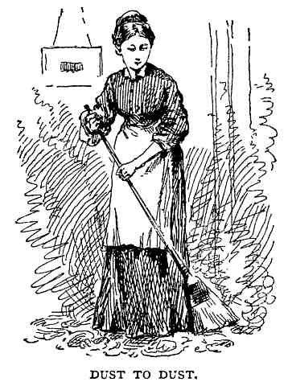

There are two ways of lessening the evil without exterminating the cause. One is to
shut the room, never using or opening it, except for the spring and fall cleaning; the other
is to lay the carpet in such way that it may be taken up and relaid without demoralizing
the entire household. Talk about the carpets fitting the rooms; there should be a margin of
two feet—a few inches, more or less, is unimportant—at each side. Then if you have a
handsome floor, the carpet becomes a large rug—no matter how elegant—that may be
removed, cleansed, and put back again every morning if you like. You may fancy a
border of wood either plain or ornamental, the surface of which shall be level with the top
of the carpet. This is easily made, either by using thicker boards around the edges or by
laying wood carpeting over the regular floor. One caution concerning fancy floors; don't
make them too fanciful. We don't like to feel that we're treading under foot a rare work of
art, and I've seen certain zigzag patterns which merely to look at fairly makes one stagger.
Thresholds are on the floor, but not of them, nor of anything else, for that matter, and
though somewhat useful in poetry, are often provoking stumbling-blocks in practice.
Necessary at times, doubtless, but we have far too many and too much of them. Even
where rooms are carpeted differently they are not needed. If you must have them, let them
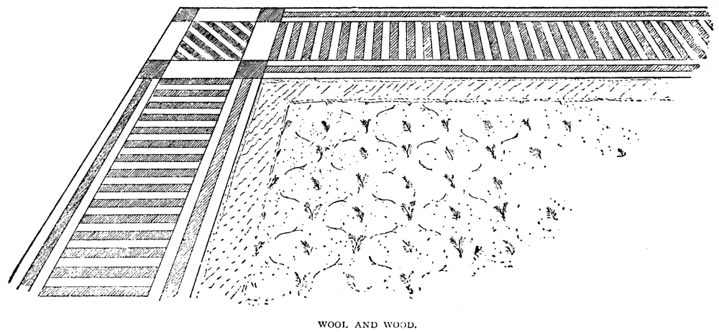
lie low and keep dark.

If you paint or paper the walls, as you will if they are plastered, keep this in mind: the
trowel finishes them as far as use is concerned. Whatever is added is purely in the nature
of ornament, and must be tried by the laws of decoration. If you enjoy seeing "a parrot, a
poppy, and a shepherdess," bunches of blue roses, and impossible landscapes, spotted, at
regular intervals, over the inner walls of the rooms, you will choose some large-figured
paper. Perhaps, if the pattern is sufficiently distinct and gorgeous, you will think you need
no other pictures; and the pictures themselves will be glad to be left out if they have any
self-respect. I'm sure you don't enjoy any such thing. Some of the fancy paper-hangings
are artistic and beautiful in design; for that very reason they ought not to be repeated. I
would as soon hang up a few dozens of religious-newspaper prize-chromos. The general
effect is the point to be considered. Why not have both? Because you can't. When you
have a picture so pretty and complete as to attract your attention and fix itself in your
memory, the general effect is lost if you discover the same thing staring at you whichever
way you turn. 'T is the easiest thing in the world to have too much of a good thing.
Sometimes the better the thing the worse the repetition. This general effect which we
must have is well secured by a small, inconspicuous figure, or by those vine-like patterns,
so delicate and wandering that you don't attempt to follow them. Better than either are the
plain tints, which give you, in fact, all you require; a modification of the cold white wall,
and the most effective background for pictures and other furnishing. As much ornament
as you please in the border at the top, and at the bottom, too, if the rooms are high
enough. All horizontal lines and subdivisions reduce the apparent height of the room.
Indeed, you may use trimming without limit, either of paper or paint, wood and gilt
moldings, provided they are well used. Color, after all, is the main thing. If there is any
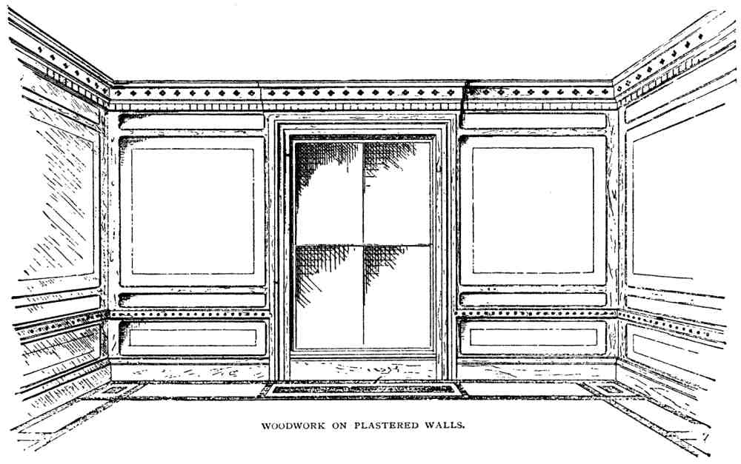
good reason for putting this upon paper and then sticking the paper to the wall, I've not
learned it. It is cheaper, cleaner, and better to apply it directly to the plastering, either in
oil or water-colors. Oil is the best; water the cheapest. In any case, the best quality of
plastering is none too good. For the papering it may be left smooth, but for painting,
especially with distemper, the rough coarse-grained surface is very much the best. The
chief objection to stucco arises from its being a cheap material, easily wrought. It is so
often introduced as if quantity would compensate for quality,—a common error in other
things than stucco. Though often desirable and appropriate, as a general rule the more the
worse. No amount of gilding will give it anything but a frail, often tawdry appearance,
that does not improve, but deteriorates, with age.

Wainscoting is always in order; it is a question of harmony, when and where to use it.
What you have in mind is really an extended and ornamented base. Of course, it enriches
the room, but it begins a work to which there is no limit. It should be supplemented by a
corresponding wood cornice at the top of the room, and between the two as much
decorative woodwork as you can afford; until "the walls of the house within, the floor of
the house, and the walls of the ceilings" are carved with "cherubims and palm-trees and
open flowers." A costly wainscot at the base of the walls, with paper and stucco above,
seems to me a great lack of harmony. I would spread my richness more evenly. In using
different kinds of wood, the raised portions, being more exposed, may be of hard
varieties, the sunken portions of softer materials, even lath and plaster, which may be

frescoed, covered with some rich colored plain paper, or hung with violet velvet,
according to your taste and means. The old-fashioned chair-rail seems to me a sensible
institution It occupies the debatable ground between use and beauty, and may therefore be
somewhat enriched. The plastering beneath it may be given a different tint from that
above, and when the walls are high its effect is good. It is really carrying out the idea of
panelling, to which there is hardly a limit in the way of variety.
Some of your questions have led me a little way from the building toward the
furnishing, but I've tried to dispose of them categorically, and am now ready for another
lot.
LETTER XXX.
From Miss Jane.
AUTOBIOGRAPHY AND ARCHITECTURE, POTATOES AND
POSTSCRIPTS.

MR. ARCHITECT: Dear Sir,—After so long an indirect acquaintance through our
mutual friends, it is quite time we were formally introduced. Allow me to present myself:
Sister Jane, spinster; native of New England, born to idleness, bred to school-teaching;
age not reported, temperament hopeful, abilities average; possessor of a moderate
competence, partly acquired, mainly inherited; greatly overestimated by a friendly few,
somewhat abused as peculiar (in American idiom "funny") by strangers; especially
interested in the building of homes, and quite willing to help Mr. Fred carry out his
ambitions in that direction by any suggestions I am able to make.


I've taught school, and I've taught music; sold goods in a store and worked in a
factory; run a sewing-machine, travelled with subscription-books, and hired out to do
house-work; and I solemnly aver that the only time I was conscious of genuine
enthusiasm for my work, or felt that I was doing myself or others any actual good, was
while keeping house. In school I was required to teach things I knew little and cared less
about, and to punish the dear children for doing precisely what I would have done myself
had I been in their places, losing all the while in amiability more than was gained in
mental discipline. My experience in a factory was limited to three months. From working
with the machines and as they worked, hardly using more intelligent volition than they, I
began to fancy myself becoming like them, with no more rights to be respected, no more
moral responsibility, and left without even serving my notice. Clerking I tried "just for
fun." If all people who came to trade were like some, it would be the pleasantest, easiest
work imaginable; if all were like others, the veriest torment. It was an excellent place to
study human nature, but made me somewhat cynical. My sewing-machine had fits and
gave me a back-ache, so I've locked it up until some one invents a motive-power that can
be applied to house-work, washing, churning, mincing meat and vegetables, driving
sewing-machines, and—if it only could—kneading bread, sweeping floors, washing

dishes, ironing clothes, and making beds. My book agency was undertaken for the
sake of travel,—of learning something, not only of the land we live in, but of its people
and homes. If I had gone from house to house and with malice aforethought begged an
outright gift of a sum equal to my commission on each book, I should have felt more self-
approval than in asking people to buy what I had not the slightest reason to suppose they
wanted.
Now I'm sure you are beginning to think me one of the disagreeably strong-minded,
who think the whole world has gone astray when it's only themselves who are out of tune,
but, truly, I'm not; only I don't like to be or to feel idle and useless, nor yet to be
constantly striving to do from a sense of duty what is positively distasteful.
Like many other important discoveries, my aptness for house-work was found out by
accident. Our next neighbor happened to be thrown, without a word of warning, into one
of those dreadful whirlpools in regard to help, to which even the best regulated
households are liable. My services, charitably volunteered as temporary relief, were
gladly accepted, and the result on my part was two years of pleasant and profitable labor.
All I earned was clear profit, and I had the satisfaction of knowing I saved the family
many times over what was paid me. I'm converted beyond the possibility of backsliding
to this truth: that there is no work so fit and pleasant, so profitable and improving, to the
mass of womankind,—rich or poor, wise or unlearned, strong or weak,—yes, proud or
meek,—as the care and control of a home; none so worthy of thorough study, none so full
of opportunity for exercising all the better bodily and mental powers, from mere
mechanical and muscular skill, up through philosophy and science, mathematics and
invention, to poetry and fine art.
From potato-washing to architectural design the distance is great, yet there are possible
steps, and easy ones too, leading from one to the other. I began with the potatoes and
know all their tricks and their manners. The accompanying sketch is the nearest approach
to architecture yet attained. A long way off, you will say; but I insist it is worthier of
recognition than the plans of amateurs who begin with the parlor and leave the kitchen
out in the cold. It is not for Mr. Fred; he must work out his own kitchen. If Mrs. Fred can't
help him, more's the pity. I give my notions of general principles; the application of them
I leave to you.
My kitchen is not merely a cook-room, nor yet the assembly and business room of the
entire household, as in the olden time. It is the housekeeper's head-quarters, the mill to
which all domestic grists are brought to be ground,—ground but not consumed. I should
never learn to be heartily grateful for my daily bread if it must always be eaten with the

baking-pans at my elbow. Indeed, we seldom enjoy to the utmost any good thing if the
process of its manufacture has been carried on before our eyes. Hence the dining-room is
a necessity, but it must be near at hand. If the kitchen cannot go to it, it must come to the
kitchen. If this goes to the basement, or to the attic, that must follow, but always with
impassable barriers between, protecting each one of our five senses. The confusion
usually attending the dinner-hour should be out of sight; the hissing of buttered pans and
the sound of rattling dishes we do not wish to hear; our sharpened appetites must not be
dulled by spicy aromas that seem to settle on our tongues; we do not like, in summer
weather, to be broiled in the same heat that roasts our beef; while, as for scents, wrath is
cruel and anger is outrageous, but who is able to stand the smell of boiling cabbage? Yes;
the kitchen must be separated from the dining-room, and the more perfect its
appointments, the easier is this separation. The library and the sitting-room are
completely divided by a mere curtain, because each is quiet and well disposed, not
inclined to assert its own rights or invade those of others; but the ordinary kitchen, like
ill-bred people, is constantly doing both. Thomas Beecher proposes to locate his at the top
of the church steeple. That is unnecessary; we have only to elevate it morally and
intellectually, make it orderly, scientific, philosophical, and the front parlor itself cannot
ask a more amiable and interesting neighbor. As the chief workshop of the house, the
kitchen should be fitted up and furnished precisely as an intelligent manufacturer would
fit up his factory. Every possible convenience for doing what must be done; a machine for
each kind of work and a place for every machine. Provision for the removal and utilizing
of all waste, for economizing to the utmost all labor and material. Then if our
housekeepers will go to school in earnest,—will learn their most complicated and
responsible profession half as thoroughly as a mechanic learns a single and comparatively
simple trade,—we shall have a domestic reformation that will bring back something of
the Eden we have lost.
Respectfully yours,
SISTER JANE.
P.S.—Surreptitiously enclosed by Mrs. John.
DEAR MR. ARCHITECT: Jane has just read her letter to you aloud for John's and my
benefit. John listened to the end without moving a muscle. When she wound up with the
garden of Eden, he got up, took off his hat (he will keep it on in the house), made a

fearfully low bow and said, "Perfectly magnificent, Jane! I begin to feel like old
Adam, already." Then he burst out laughing and took himself out of the room, leaving the
door wide open, of course, and kicking up the corner of the door-mat. You see he's one of
those men who think home isn't home-like unless it's sort of free and easy. He'd be
perfectly willing to eat and sleep and live in the kitchen,—if I had the work to do; and
though he likes pretty things, and would feel dreadfully if I didn't look about so, has a
perfect horror of smart housekeepers, and thinks women who care for nothing else the
most disagreeable people in the world.
The trouble with Jane's letter is that she doesn't go into particulars enough, and that's
why I want to add a postscript. I wish I could describe the kitchen in the house where she
has been living. The people had so much confidence in her judgment, that they just
allowed her to fix things as she chose, and it's really quite a study. It mightn't suit
anybody else, but it shows what may be done.
She began by taking one of the pleasantest rooms in the house, although 'twas in the
basement, and had windows cut to bring them on the south and east sides. Then she had
an outside door at the south with a wide piazza over it, which made the room actually just
so much larger. Across one side of the room is a wide stationary table,—I suppose men
would call it a work-bench,—with a fall-leaf, in front of one of the windows, especially
for an ironing-table. Of course it can be used for anything else. One part of it is about
eight inches lower than the common height, where ever so many kinds of table-work can
be done sitting. Underneath the higher part are drawers and places for all the things that
are useful about the laundry-work. Her sink is in the midst of a perfect cabinet of
conveniences. There's a hook or a shelf for every identical rag, stick, dish, or spoon that
can be used or thought of; shelves at each side, and drawers that never by any possibility
will hold what doesn't belong in them. One thing she won't have; and that's a cupboard
under the sink for pots and kettles. She says it's impossible to keep such a place clean and
sweet. Things are shoved into it sooty and steaming to get them out of the way, and it
soon gets damp and crocky beyond all hope of purification. Hot and cold water run to the
boilers and kettles, and there's a funny contrivance for sprinkling clothes. The washing
almost does itself. The tubs are of soapstone, at the opposite side of the room from the
ironing-table. Over the entire stove—she might have had a range, but didn't want one—
there's a sort of movable cover with a flue running into the chimney that carries off every
breath of steam and smoke from the cooking. One would never guess at the dinner by any
stray odors. It is made of tin; the kettles boil quicker under it, and it makes the room a
great deal cooler in summer by carrying the extra heat off up the chimney. She has a place
for the bread to rise, and a cupboard close by for all the ironmongery belonging to the
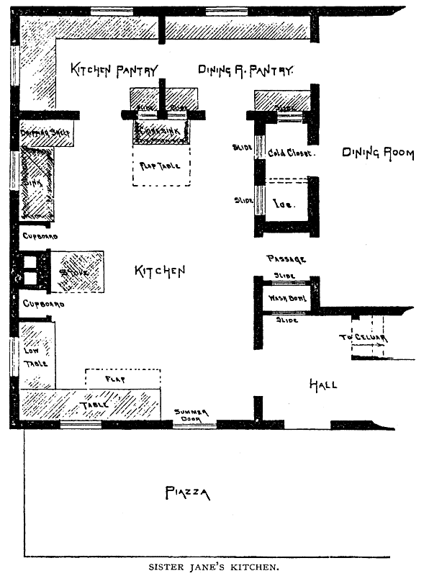
stove, zinc-cloth and blacking-brush included.

Her pantry I won't undertake to describe. It adjoins both dining-room and kitchen.
John says she never does anything in getting dinner but just sit down in an easy-chair and
turn a crank. That's one of John's stories, but she certainly will prepare a meal the
quickest and with the fewest steps of any person I ever knew. The funniest thing about it
is, that I've known eight people at work in the room all at once without being in each
other's way one bit. But that's no closer than men work in their shops.
Jane intends to stay with us this winter, and I expect we shall have jolly times, for
we're going to board the schoolmaster. If he calls to see you, as I think he will, I want you
should read Jane's letter to him. She would take my head off if she knew I mentioned it,

but I think he ought to know what's before him.
Respectfully,
MRS. JOHN.
P.S. No. 2.—Unnecessarily appended by John.
MY DEAR ARCHITECT: If we've got to go through the whole establishment on
transcendental principles, I shall send in my resignation straight.
Sister Jane's a regular trump; Penelope and queen of Sheba rolled into one. But when
the women-folks begin to preach, I always find it best to keep still and consider my sins. I
haven't had a chance to say much lately, but I've kept up a tremendous thinking, and when
I do get the floor look out for me. How do you happen to know so much about the
millennium?
Yours patiently,
JOHN.

LETTER XXXI.
From the Architect.
DOMESTIC-SERVICE REFORM.

Dear Miss Jane: Your very kind letter was received and gratefully appreciated. As the
world grows less ignorant and wicked, we should naturally expect missionaries and
reformers to find their occupation going, if not quite gone; that modern reforms would be
mere play compared with the stern and mighty movements that in former times have
blessed mankind and balked the Evil One. But somehow the need for missionary work
seems greater every year. We are not even permitted to go to the heathen. They come to
us without waiting for an invitation; if not as pupils in the lessons of civilization, they

come as teachers. Sometimes they are aliens, sometimes our own kith and kin. To keep
what we have won and gain the next height requires new zeal, and ever greater efforts,—
requires the very work you are doing; for a well-ordered home, though it consist of but
two members, is a tremendous missionary society. The light streaming from its windows
is an ever-burning beacon of safety to our most cherished social institutions.
First and chiefly, this essential home work needs to be taken from the hands of
indifferent, careless servants and confided to those who realize the nobleness of the
responsibility, and will strive to meet it faithfully. Ultimately, the ignorant, careless ones
must be taught, but that will never be till culture is a manifest necessity and finds a fit
reward. When a man undertakes the charge of a new business, he learns, not only its
general principles, but as far as possible, its minutest details, otherwise he fails inevitably,
and the place is given to his well-qualified competitor. If our prospective housekeepers
were amenable to similar rules, the competent mistresses of this most useful art would
find plenty of apprentices glad to serve them long and well for their tuition, and if those
who have now the care of households will patiently instruct their help, they will find
abundant recompense in a more faithful and efficient service.
Doubtless we must wait a little longer for our lost Eden to be restored by the angels of
the household; but, in the hastening of that good time, such examples, permit me to say,
as your own will be worth far more than any multiplying of conveniences and labor-
saving machines for the benefit of those who do not know or care to learn how to use
them,—examples of the nobleness, the gentility if you please, of all useful labor. Until
that everlasting truth is understood and applied, there will be more need of your teaching
than of my plans. If you will teach your neighbors what a fully equipped home building
should contain, I will try to show them how their wants can be supplied. Teach them, at
the same time, what it need not contain. As certain folks do not understand how heaven
can be enjoyable without a Tartarean attachment to which all disagreeable people and
performances are consigned, so a common notion of home, that earthly epitome of
heaven, appears to be that it should also contain an abridgment of the same direful
institution; that there must be somewhere in the house a place of torment, the angels who
abide therein, giving us our daily bread and doughnuts, being of a totally different type
from the glorious creatures singing songs of praise and operatic melodies in the upper
stories. That the genius of the kitchen and the parlor can be one and the same is a
conception too stupendous for the average understanding.
This, too, I hope you will insist upon. Every man who would build himself a house
shall first sit down and—not count the cost, that comes into my department, but—ask

himself solemnly what the house is for. To live in, of course. But living is a complex
affair; it is constant growth or gradual death; there can be no standing still. Is the house to
be an end, or a means; a help to make the life-work larger and better, or an added burden?
Shall it lift, or crush him? When this solemn questioning is honestly done, we shall have a
new order of domestic architecture. It may not be classic, neither Grecian nor Roman,
Gothic nor French, but the best of all that has gone before and the last best thing thrown
in. We shall have more cheap houses, more small ones, I think; more comfort and less
show, more content and fewer mortgages.

LETTER XXXII.
From Fred.
GO TO; LET US BUILD A TOWER.

MY DEAR ARCHITECT: I've been hearing a variety of suggestions from Miss Jane,
the substance of which she has already forwarded you in a letter. Her ideas are excellent.
They ought to be adopted in every household. I wish to have them carried out as far as
possible in mine, when the time comes. She favors a basement kitchen, which I had
always thought objectionable. If adopted it would change my arrangement considerably.
What do you think of it? How high shall I have the different stories, and will you give me
some hints for exterior? I intended to have a tower or a cupola, but after so much change I
hardly know where I am coming out. There is something very imposing about a tower,
and a cupola seems to finish the house handsomely, besides affording fine views. I feel
decidedly partial to French roofs, but have seen some very awkward ones that I should be
sorry to imitate. They give excellent chambers and have a modern look. The latter point I
suppose you will not think important.
Truly,
FRED.

LETTER XXXIII.
From the Architect.
BASEMENTS AND BALCONIES.

Dear Fred: Of course Miss Jane's ideas are good. When a woman honestly tries to
understand her work and do it well, she is sure to succeed, especially in this matter of the
equipments of home.
The basement arrangement depends mainly on the location. When this is favorable it is
undoubtedly economical, nor is it necessarily inconvenient or unpleasant in any way, but
quite the reverse. You are fortunate if your site will allow it, for it adds enormously to the
capacity of the establishment. At least two sides of this lower story, "basement" you call
it, should be above ground to insure dryness and plenty of light. Then all the heavier work
of the house, including the eating and drinking, can be done on this floor, leaving the
upper stories intact for loftier purposes. The old-fashioned cellar as a storehouse for a
half-year's stock of provisions—bins, and barrels by the dozen, of potatoes, apples and
cider, corned beef, pork, vegetables, vinegar, and apple-sauce—is extinct. Hence the
space once thus occupied is almost a clear gain if made into finished apartments,—an
economy that will commonly allow a family room on the next floor, whereby the going
up and down stairs is no more serious than if both are one story higher. The sketch is an
illustration of what the basement adds. The capacity of the little house is more than
doubled by it, while in point of style the augmentation is even greater than in room.
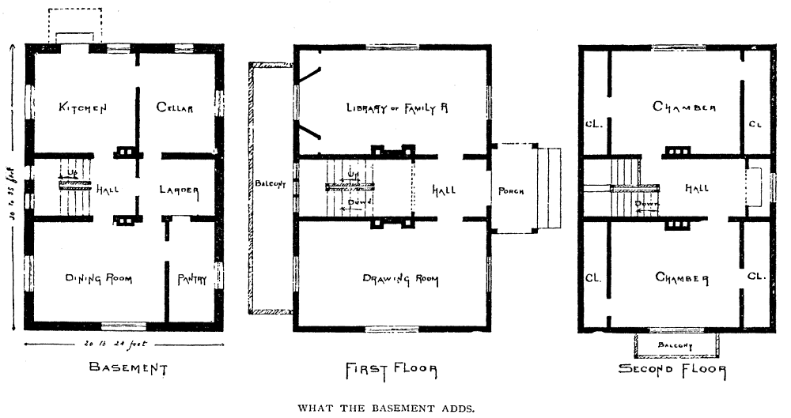

As to height of stories, you are quite as liable to make them too high as too low. For
rooms within the common limits of size, ten to eleven feet in the clear is enough. Even
nine is by no means dangerous. If too high for their area, they seem like large closets,
giving a feeling of being walled in, hardly less unpleasant than the low-hanging ceilings
of the last century. I know the argument of better ventilation. But that depends. The old,
seven-foot rooms, with their huge fireplaces, big enough to hold a load of wood, ox-team
and all, undoubtedly held purer air than is found in the hermetically sealed apartments of
the present time, whose ceilings are out of sight.
As you say, a tower is often very imposing. It is not always certain who feels the
imposition most heavily, the man who pays for it or the man who looks at it. They are not
only imposing, but they contain six or seven stories, one above another, of eight-foot
square rooms, deducting a Jacob's-ladder stairway at one side, whereon people climb to
the topmost room for the sake of looking out in the wrong direction through a round
dormer-window, scratching their heads in the mean time on the nails that come through
the roof! Cupolas too are lovely,—especially on a barn,—and top off a house in the
daintiest fashion possible; just as, to set forth great things by small, the "knob" on the
sugar-bowl cover finishes the sugar-bowl. Many houses do appear unfinished without a
cupola, and I'm sorry for them, because when the cupola is built it looks so much like the
handle on a big cover that I half expect some giant to come along and lift it off to take a
peep at the curious animals underneath. For, truly, they are curious animals, and build
some curious nests. I like, as well as you, to get up above my neighbors now and then,
and look down upon them. I never see a tall chimney or church spire without wishing
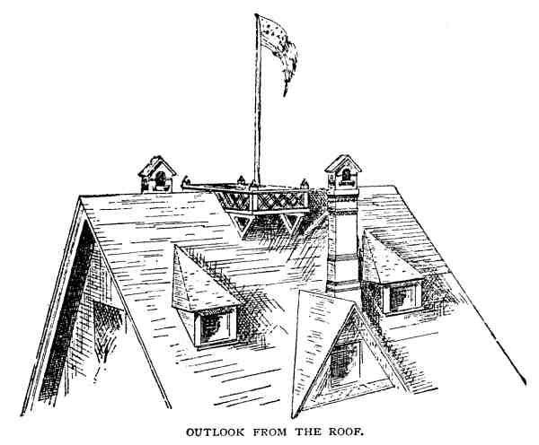
there was a spiral staircase around the outside of it, from which to view the landscape
o'er. In fact, to be candid, if I had happened to live a few thousand years ago, I am afraid I
should have taken stock in the Babel enterprise, not really expecting to leave this
terrestrial ball in that way, but just to see how high we could go. The audacious tower of
the Centennial I shall certainly patronize. But on domestic buildings, unless for better
adaptation to the site, or for some special use, there are other things more to be desired
than these lofty appendages. An open balcony, hanging from the highest point of the main
roof, just below the scuttle, or the flat, if there is one, on the top of the whole, surrounded
by a protecting balustrade, affords a better place for observation and costs less than those
laborious affairs whose use and beauty often neutralize each other.

How dare you think anything claiming to be a French roof ugly to look at? People who
are fond of that style admire them from a sense of duty, because they are French roofs.
Perhaps if I was a Frenchman I should like French roofs, too; being an American, I like
American roofs better. You do, however, give one reason for your preference,—the
complete chambers,—which is merely another way of saying you like three stories better

than two,—a good argument, by the way, for the basement, which is surely more
convenient than an attic. I enclose a sketch, intimating an outline and style that will suit
your location. The roof, which is not French, either in form or
costliness
, will contain all
the dormitories and store-rooms you can use, unless you propose keeping a three-story
boarding-house.

LETTER XXXIV.
From the Schoolmaster.
FOUR ROOMS ENOUGH.

MR. ARCHITECT: Dear Sir,—Once, in conversation with you, I made some inquiries
as to the feasibility of building houses, especially of brick, with reference to future
enlargement. My present ambition is bounded by a house of four rooms. One in which all
the household work shall be done, including the eating. It shall contain the cooking-stove,
the dining-table, laundry conveniences, etc., and may be called kitchen, dining-room,
laboratory, or simply work-room. An apartment to be used solely on account of its
facilities for doing house-work. It should be of good size, and a pleasant outlook is
desirable, but not necessary. A second room for ordinary and extraordinary use; to sit in,
to talk in, to read and write and visit in; the books are kept in it, and the sewing-machine,
the piano and the flower-stand, the birdcage and the pictures; a large, pleasant room,
where the sunlight loves to shine in upon us and we love to look out upon the sunshine. It
is parlor, library, drawing-room, living room; in fact, it is the house itself, to which
everything else is accessory. A family sleeping-room, sunny, simple, and airy, and a
guest-room of similar character, complete the establishment. More than these four
principal rooms would be a burden, less would hardly suffice for comfortable living. The
problem is to arrange a plan that shall be convenient and complete before it begins to
grow, and to which future additions may be made without serious loss. I also want
counsel concerning ventilation, both on general principles and with reference to the

unfortunate box in which I am daily compelled to breathe my own breath over and
over, variously flavored with the commingled exhalations of sixty pupils, with whom I
grow cross, restless, or stupid, according to the state of the school-room atmosphere. I
believe it is just as wicked to allow children to breathe impure air in their school-rooms or
their bedrooms as it would be to put poison in their dinner-pails and require them to
swallow it.
My friend, Mrs. John, takes a kindly interest in my quadruple plan, and assures me it
will be quite sufficient for a sensible housekeeper. Do you suppose such a one can be
found?
If convenient, I will call upon you in a few days.
Truly yours,
SCHOOLMASTER.

LETTER XXXV.
From Mrs. John.
CONVENIENCES AND CONJECTURES.

Dear Mr. Architect: The building-fever seems to be contagious in our neighborhood.
The teacher who boards with us is the latest subject. He pretends it's all for fun, but has
been studying plans for weeks, and now, after getting the advice of the entire household,
is going to throw it all away and apply to you, as he should have done in the first place. I
overheard him explaining to Jane how the cooking-stove is to be in a sort of recess by the
chimney, with tin-lined doors to shut it out of sight; the wash-boiler at the opposite side,
enclosed in the same way, and having a contrivance overhead to carry off the steam; how
there are to be cupboards at each side of the wide window, making it a sort of bay, with a
wood-box window-seat; how the sink is to be converted into an elegant sideboard by an
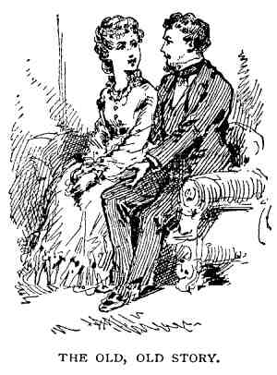
ornamental cover, and everything else in the room contrived so it can be shut up or
folded up out of sight when not in use. Of course Jane assists, and the combined wisdom
of the two is something appalling to ordinary mortals. I should certainly think the affair
was getting serious if anything of the kind ever did turn out as other folks think it ought.
They are wonderfully harmonious now, but I don't believe Jane will ever be satisfied
without a separate dining-room.

John wishes me to ask what he shall do about warming his house. Says he has not
decided whether to have fireplaces or stoves, grates or a hot-air furnace, steam, hot water,
solar heat, or depend on a scolding wife to keep things warm.
Yours truly,
MRS. JOHN.

LETTER XXXVI.
From the Architect.
THE LESSON OF THE ICE-HOUSE.

MRS. JOHN: Dear Madam,—Without doubt the affair is getting serious, but do not
give yourself any uneasiness as to the issue. The Divinity that shapes our matrimonial
ends is, happily, a wiser power than that which designs our houses, however it may
appear to outsiders. Your friend talks like a gentleman and a scholar. I admonished him
discreetly, promised to study his interesting problem and give him a chapter on
ventilation; which, by the way, is so intimately connected with warming, that I may be
obliged to make a sort of company letter in answering your husband's inquiry on that
subject. Tell him, in brief, to use fireplaces if he has a hundred acres of wood-land to
clear up; stoves, if he can live without air; grates, if he doesn't mind the trouble and the
ashes; furnace, if he can set it directly under each room and can find one that won't
strangle him some windy night with poison gases; and steam or hot water, if he can run a
machine-shop and keep a competent engineer. Solar heat may be more available than he
thinks, but his doubt as to the last-named mode proves that he has no experimental
knowledge of it. Neither have I.
Tell him also to protect his family as carefully as he protects his ice, and the house-
warming will be a simple matter. The conditions are identical, only turned inside out. In
one case the heat is to be kept from penetrating, in the other from escaping, and both
require the same treatment; not, perhaps, to the extent of stuffing with sawdust,—
confined air is just as good,—but the walls and the floors, the roofs and the windows,
should be made to prevent the escape of heat. He may think I underrate his scientific
attainments, but it will do no harm to remind him that an air-tight house may be a very
cold one. A man would freeze to death in a glass bottle, when a coarse, porous blanket
would keep him comfortable. Double windows are not to keep cold air out, but to keep
the heat in. India-rubber weather-strips have, doubtless, caused ten times as many
influenzas as they have prevented. More heat will radiate through a window of single
glass than would be carried out by the air through a crack, half an inch wide, at the side of
it.
These suggestions are "just to set him a thinking."

LETTER XXXVII.
From John.
SHINGLES, SUNSHINE, AND FRESH AIR.

MY DEAR ARCHITECT: When I stepped into the background, I didn't propose to be
left entirely out in the cold. I've followed Fred through the most of his gropings after
grandeur, and listened patiently to one of Jane's dignified essays on the sublimity of
housekeeping; but when my wife begins romancing, and the schoolmaster is allowed to
run wild, as though his moonshine was brighter than that of other folks, I think it's time to
call the meeting to order.
While you have been gossiping I have been at work, and now our house is almost
done,—that is to say, it's well begun. The stone walls of the first story are finished, the
frame is raised and covered. I've done one thing without asking anybody's advice;
covered the roof with the best cedar shingles I could find. I hired an honest man to lay
them, who would throw out all that were dubious and lay the cross-grained ones right side
up, and painted the tin valleys both sides before the shingles were laid. Then I took the
difference in cost between this and a good slate roof and put it in the savings-bank. At the
end of twenty years, if my roof lasts as long, my deposit will put on the best kind of a
slate roof and leave three hundred dollars to go to the Society for the Promotion of Fine
Art in General and Rural Architecture in Particular. I know the shingled roof may burn
me up, if the chimney should happen to take fire some windy night, but 't won't cost so
much for repairs as slate if they should blow over, either all at once, or one brick at a
time. My neighbors may not like the looks, especially while it's new; but if we have
nothing uglier than a mellow gray-shingled roof, I don't think anybody'll be hurt. I wish
we had something like the tile roofs I've seen in foreign pictures. They'd go first-rate with
my stone walls.

The eave-spouts bother me. I don't need to save the water from the roof, and have
concluded to let it pour where it pleases. The porches protect the doorsteps, and I think it
will be easier to take care of it after it falls than to hang gutters all around emptying at the
corners and angles. They are troublesome things anyway. The leaves clog them, the ice
dams them, the snow comes down in an avalanche and smashes them, they fall to leaking
and spoil the cornice, and after they are all done there's no certainty that the water won't
run the wrong way. I can put them up afterwards if necessary, but don't believe it will be.
The last counsel you gave me was to open the eyes of my house for the daylight to
shine through without let or hindrance. I'm beyond advice on that subject. Carpets and
curtains shall fade rather than wife and babies. My windows yawn like barn-doors. There
isn't a room in the house that won't have the sun a part of the day, and he looks into the
sitting-room from the moment his cloudy bedclothes are thrown off in the morning, till he
hides his face behind Mount Tom at night. My glass bill will count up, but I'd rather pay
for glass in windows than for iron in the shape of tonics.
Now, if you will settle the question of warming and ventilating you shall be honorably
discharged. Don't try to show off your science by telling me how carbon, the wicked,
poison stuff, is heavy, and we must leave a hole near the floor where it can run out and be
coaxed up to the ridgepole after it gets cold, and then make pictures covered with arrow-
heads to show how well-educated air ought to go! Talk as many gases as you please to
other folks. I know two or three things for certain. Coal costs ten dollars a ton; that's one.
I want just as large a house in winter as in summer; that's another. I mean the whole house
must be comfortable, in shape to use when needed. I know a man will be cut off suddenly
by his own breath if he has nothing else for his lungs. Mixing fresh air with it will
prolong his career more or less, but it's only a question of time when he shall give up the
ghost if he attempts to subsist on anything less simple and pure in the way of respiration
than the out-door atmosphere. That's bad enough in some places. What I don't know and
want you to tell me, is how to keep cool in summer, warm in winter, and at the same time
have all the fresh air we can possibly consume. I know how to keep warm: build a tight
room, keep it shut up, set a box stove in the middle of it, and blaze away. A ton of
anthracite or a cord of hickory will keep you warm all winter, especially if you die before
spring, as you probably will. I know how to have fresh air too: open the windows and let
it blow; but unless a man lives down in a coalmine he can't well afford to keep warm
under such circumstances.
I believe this question is the chief concern of builders here below, and whoever invents
an economical solution of it will not only make a fortune, but he'll deserve one. Why

don't you go for it?
Yours,
JOHN

LETTER XXXVIII.
From the Architect.
WHEN THE DOCTORS DIFFER.

DEAR JOHN: Your economical reasons for using shingles would justify cheap
jewelry and rag carpets. Try to be consistent. I should object to slate on a log-barn or
shingles on a stone-house. I hope you furnished your honest carpenter with a stout jack-
knife, and required him not only to lay the shingles right side up, but to lay the upper ends
close together, leaving them apart at the butt. Gutters are troublesome truly, but often
indispensable; there is no resource but to have them thoroughly made. Poor ones are
worse than none. Those that hang independently of the cornice are safest for cheaper
buildings, but should be treated as an essential feature; that is, you should not complete
the cornice without a gutter and afterwards disfigure it by a sloping spout having no
apparent kinship to the rest of the finish.
The problem of warming and ventilating is easily solved for those who desire its
solution sufficiently to make the necessary appropriations. One quarter of what is
commonly spent for vanity and deceit will be ample. Most men and women, at least the
unthinking, prefer fashionable show rather than health! A fearful statement, but sadly
true. There is doubtless more danger from impure air than from cold. Our senses warn us
quickly of the latter; the prompting of knowledge is needed to guard us against the
former,—of a practical knowledge unfortunately rare. Men, women, and children are
dying daily through ignorance and indifference on this subject. There is hardly a school-
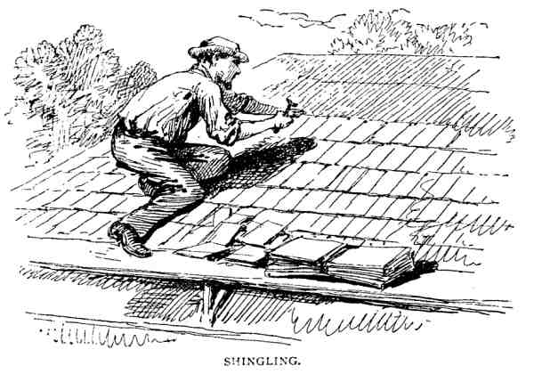
house to be found in which the murder of the innocents is not continually rehearsed,
hardly a church in which the spiritual elevation resulting from attendance therein is not
counterbalanced by an equal physical depression, and rarely a hall or lecture-room
wherein an audience can even listen to a physiological discourse on the fatal effects of
impure air without experimentally knowing that they are listening to solemn truth; while
as to the dwelling-houses, the homes of the dear people, it requires no bloodhound's scent
to distinguish them one from another! The moment the front door is opened to me, I am
assailed by the odor peculiar to the establishment. It may be tuberoses or garlic, mould or
varnish, whitewash, gas, lamp-smoke, or new carpets, a definite and describable or an
indefinite and indescribable fragrance, but it is sure to be something besides pure fresh
air.

Let me give you first a suggestion for summer ventilation. Did you ever shingle the
south side of a barn on a calm, hot, sunny day in July, thermometer at ninety degrees in
the shade? Did you ever lay your hand on a black slate or tin roof exposed to the direct
rays of a midsummer sun? Have you ever, at the close of some hot, labor-spent day in
August, sat out of doors until the evening air became deliciously cool, and then climbed
to your attic dormitory, there to spend a sleepless night in perspiration and despair,
anathematizing the man who built and the fate which compelled you to occupy such a
chamber of torment?

Now, there is no good reason why the rooms immediately under the roof of a house
should be any more uncomfortable on account of heat than those of the first story. Nay,
more, by the simplest application of common-sense, these upper rooms may be so coolly
ventilated that the hotter the sun pours his rays upon the roof the more salubrious shall be
your palace in the sky. And this I call a triumph of genius, making the seemingly
destructive wrath of the elements to serve and save us.
M. Figuier tells us with just how many hundred thousand horse-power the sun, by the
caloric of its beams, operates upon the surface of the earth. I cannot tell precisely how
much force is spent upon the roofs of the houses that cover so much of the good mother's
bosom in certain localities, but I know that it is wonderfully great, and that rightly
controlled it will make the space immediately under these roofs cool instead of hot.
And this is the way to cause the heat of a burning sun to cool the attic chamber: Make
the space between the rafters on the sunny sides of your building as smooth and
unobstructed as possible. Arrange openings into the outer air at the lower end of each,
simple or complex, according to your taste and ability. Provide also means for closing the
same in cold weather. Be sure that these spaces, or flues, are enclosed either by lath and
plaster, or by smooth boards, quite to the highest part of the roof, whether your rooms are
finished to the top or not,—and provided with an abundant outlet at the top. This may also
be as simple as the dorsal breathing-holes of a tobacco barn, gorgeously imposing as an
Oriental pinnacle, or it may be a part of the chimney; only let it be at the very summit,
ample, and so arranged that an adverse wind shall not prevent the egress of the rising
currents of air. Mind this, too; it is by no means the same thing to let these flues open into
a loft over the attic rooms, with windows in gables or other outlet.
Now, do you not see that as soon as the sun has warmed the flues, there will be a stiff
breeze blowing, not over the roof, but really between the roof and the house, and the
hotter the sun the stiffer the breeze; in the words of one who has tried it,—"a perfect
hurricane." That is, the lath and plaster, or sheathing, which forms the inner roof, is
shaded by a canopy of slate, shingles, or tin, and fanned by a constant breeze as cool at
least as the outer air. But we can do vastly better than that. Instead of opening the lower
ends of these flues to the outer air, they may be extended wherever the needs of the house
require, or its construction will allow.
Let me remind you, under the head of general principles, that there is no such thing as
"suction." Of course, you know it when you stop to think, but bear it in mind, and
wherever the motive-power seems to be applied on which you rely to lift the column of
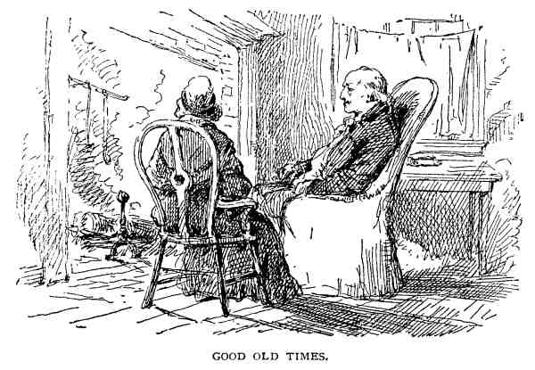
air, remember that if raised at all it must be raised from the bottom. Maybe you will
discover room for a moral here.
This summer ventilation is simple enough, and relates rather to comfort than to health.
The great question in building, for New England and similar climates, is, indeed, how to
keep our houses warm, and, without great expenditure of fuel, have a constant change of
air. As you suggest, we have learned that wood costs eight or ten dollars a cord instead of
the mere labor of cutting and hauling; hence we have shut the mouths of the old-time
fireplaces, mouths that it would cost a fortune to feed. We find the value of building-
timber increasing every year; so we make thinner walls, lined outside and inside with
paper, and have cold houses, no fresh air, anthracite coal, and disease. Our grandfathers
carried foot-stoves to church, where they sat and shivered, sometimes with the cold,
sometimes at the doctrines. We have warm air and stale. Let us hope our children will
have warmth and freshness for body and soul. They, in their homes, had big fireplaces,
loose doors, rattling windows, cracks in the walls, and as they lay in bed looked at the
stars through the chinks in the roof, or felt the snow blow on their cheeks which were
ruddy with health and vigor. We have cylinder stoves, double windows, tight walls
plastered and papered, and pale faces.

Yet we build and furnish more wisely than our ancestors. They ventilated because they

couldn't help it, couldn't afford to build as we do, and could afford to burn an acre of
woodland every year.
It is no light task you have set me preliminary to an honorable discharge. Next to
theology and government finance there is no subject on which the doctors differ and
dogmatize as in this matter of warming and ventilating, most of them preferring that the
universe should suffocate rather than their pet theories and furnaces be found wanting.
(I'm not speaking of the theologians.)
Let me restate a few general principles, simple and obvious, yet so important that we
must not risk forgetting them. Air runs away with heat fast enough if allowed to move.
Confined it is a more effectual barrier than granite walls and plates of steel. Hence the
spaces in the wall should not extend its whole height unless for local ventilation. Cut
them off surely at each floor, and as much oftener as you please; also make the floors
tight and warm. Deafen with mortar if you can afford it, and do not allow the open spaces
between the floor-timbers to extend unbroken through the house, or fail to close them
between the rafters when the ceiling of the highest story is above the plates. If you wish to
warm the entire house, it will be good economy to lath and plaster along the under side of
the rafters quite to the ridge-pole. Finally put on your double windows, and you are ready
for winter quarters.
In theory, the house being once warmed, the temperature within should scarcely
change, even if the fire goes out. Practically, the walls cannot hold this subtile caloric,
however scientifically they are padded. There will be crevices, too, though the prince of
joiners builds your house, through which the warm air will escape. But replenishing this
inevitable loss would be a small matter, if the breath of life were a needless luxury.
Unless, however, we are willing to suck poison into our veins with every breath we draw,
slow but sure,—poison expired from our lungs and emanating from our bodies, poisonous
gases liberated by the combustion of fuel, poison dust and decay from the waste of
inorganic material,—we must have a never-ceasing supply of fresh air around us
everywhere and always. Now this incoming fluid, cold as ice, eats fuel like a hungry
giant, yet we must receive it with open arms, and, as soon as fairly warmed, send it off
through the ventilating flue, bearing whatever noxious elements may chance to be afloat,
and, of course, much of the warmth we love and buy so dearly. We have then to supply
these three sources of loss. Obviously for economy the two former must be prevented to
the utmost, the latter rigidly controlled.
Thus far, except the old fogies who don't believe in ventilation, we can all travel
together harmoniously. Now our way divides, the doctors begin to differ, and the patients

begin to die.
The first fork is at the two modes of warming, direct and indirect. The former includes
stoves of all sorts,—sheet or cast iron, porcelain, soapstone, brick or pottery, box or
cylinder, for wood or coal, air-tight, Franklin, "cannon," or base-burner, parlor cook or
kitchen cook, charcoal basin, warming-pan or foot-stove,—anything in which you can
build a fire. It includes open grates and fireplaces, ancient or modern, large or small; it
includes steam-pipes, hot-water pipes, and stove-pipes; and last, but not least, steam-
radiators, than which it has never entered into the heart of man to conceive anything more
surprising and unaccountable,—flat, pin-cushiony things, big as a bedquilt, dangerous-
looking hedgehoggy affairs, some huge and bungling, others frail and leaky, but radiators
still. In brief, the heating apparatus, whatever it may be, stands in the room to be warmed.
By the indirect mode it is enclosed in a chamber more or less remote, commonly
called a furnace, and made of brick, sheet-iron, or wood lined with tin. Into this chamber
cold air is admitted from some source, and escapes by its own levity, usually through tin
pipes, to the rooms where the heat is needed. Sometimes it is driven out by mechanical
means.
The advocates of the latter indirect mode claim for it many advantages. It is apparently
clean. There are no ashes to be taken up, no hearths to sweep, no andirons to polish, no
stoves to black. One fire will warm the entire house if well arranged, and, for a trump
card, there may be a supply of fresh air straight from the north pole, but agreeably
warmed, constantly entering the room.
The objections are less numerous but more weighty. The liability to imperfect
construction and careless management often makes a furnace, especially a cast-iron one, a
savor of death unto death rather than of health and comfort; also, when we are warmed by
air thrown into a room at a high temperature, and dry at that, a greater degree of heat is
necessary for comfort than if our bodies and clothing absorb heat from a radiating
surface. The furnace, in short, compels us to breathe an atmosphere highly rarefied. We
have the most careful and competent authority for believing this to be gravely injurious.
Direct radiation from stoves, or other heating apparatus, except open fireplaces, is,
moreover, economical of fuel, but, on the other hand, unless abundant ventilation is
provided, the atmosphere in rooms thus warmed soon becomes unfit for respiration.
Now you may stop and think. Next time you shall have the conclusion of the whole
matter.

LETTER XXXIX.
From John.
HOW TO DO IT.

MY DEAR ARCHITECT: I'm in a hurry. Let me ask you a few square questions. Give
me square answers if you can; if not, say so. What kind of a furnace shall I get? I've
interviewed about a dozen; each one is warranted to give more heat, burn less coal, leak
less gas, give less trouble and more satisfaction, than all the others put together. I suppose
you object to cast-iron, because it's liable to be heated red-hot and burn the air.
Is wrought-iron any better?
Shall I put the registers in the floors or in the partitions?
What do you say to steam?
How shall I ventilate?
Will it answer to have the ventilating flues in the outer walls?
There seems to be no doubt that the foul air should be drawn from the bottom of a
room; but if it's cold, how am I to get it to the ventilator on the top of the house? If a room
is as tight as a fruit-can, a chimney might draw like a yoke of oxen without doing any
good, and Nebuchadnezzar's furnace wouldn't drive air into it unless, in both cases, the
inlets and outlets were about equal! When I go to sleep in such a room I want to be sure
the dampers won't get accidentally shut.
Give me your opinion on these points, but don't make a long story or a tough one. If a
house is to be kept warm from turret to foundation-stone, I don't see that shutting up the
spaces between the timbers would amount to much, except to stop sounds from echoing

through them; but when the attic is as cold as out-doors, it's plain that the cold air will
be always crawling down next the inside plastering of every room in the house if it finds a
chance.
Yours,
JOHN.

LETTER XL.
From the Architect.
THE BREATH OF LIFE.

DEAR JOHN: No man ever built himself a house without getting out of patience
before it was finished.
Among all the furnaces you have examined, a certain one is doubtless better for you
than any other; when I find out which one, you shall be informed. Reliable testimony on
the subject can only be given by some one who has tried different kinds in the same house
under similar circumstances for a considerable time. As we never have two seasons alike,
and do have about three new first-class furnaces every year, it is difficult to find this
valuable witness. Printed testimonials are worth three or four cents per pound. I do not
know that cast-iron furnaces are more liable to be overheated than others, and you cannot
"burn the air" with them if they are, unless you burn the furnace too. You may fill a room
with air, every mouthful of which has been passed between red-hot iron plates, not over
half an inch apart, and I do not suppose the essential properties of the air will be
perceptibly changed, or hurt for breathing when properly cooled.
The danger from cast-iron is in its weakness, not in its strength.
You speak of poison carbon. Carbonic acid is not poison. It is harmless as water,—

just. It will choke you to death if you are immersed in it. Trying to breathe it in large
quantities will strangle you. But we drink it with safety and pleasure, and may breathe a
little of it, even as much as thirty per cent, for a short time, without serious harm. But
carbonic oxide, which is also liberated from burning anthracite, is an active poison, and
one per cent of it in the air we breathe may prove instantly fatal. Now it is fully proven
that these gases laugh at cast-iron and pass through it freely whenever they choose.
Wrought-iron plates are supposed to be more impervious. The popular notion that foul air
must be drawn from the bottom of a room is based, I think, upon a superficial knowledge
of the weight of carbonic acid, an ignorance of the law of the diffusion of gases,—upon a
realizing sense of the cost of coal, and an insensibility to the worth of fresh air. Even such
unreliable witnesses as our senses assure us that the air at the top of a high room—say the
upper gallery of an unventilated theatre—is far less salubrious, though not overheated,
than that below. We know, too, how quickly the sulphurous gas that sometimes escapes
from those warranted furnaces not only ascends through the tin pipes, but rises in the
open stairway if it has a chance. The hurtful carbonaceous gases doubtless go with it, and
are then diffused through the room. The most forcible objection to allowing the air to
escape through the ceiling is that it is a wanton waste, not only of heat, but of the fresh air
that has just come from the north pole by way of the furnace and cold-air box, and which,
by virtue of its warmth, goes in all its purity straight to the ceiling. Accordingly the heavy
cold air lying near the floor and laden with poison must be drawn out through the
ventilating flue, till the upper warmth and freshness fall gently on our heads, like
heavenly blessings.
Let me digress here to answer another question. No, don't put your ventilating flues in
the outer walls if you expect the air to rise through them in cold weather; for it will not, if
they reach the moon, unless it is warmer than that lying at their base. You may as well
expect water to rise from the cistern to the tank in the attic because the pipe runs there, as
that air will rise simply because there is a passage for it. Sometimes holes are made into
the chimney-flues, but this is robbing the stoves or the fireplaces. It is better to build an
independent flue so close that it shall always feel the heat from the black warm heart of
the chimney, for warmed by some means it must be. Yet warm air does not choose to rise.
It falls like lead unless lifted by something heavier than itself.
To return to the former point. When you can warm within a ventilating flue all the air
passing through it more economically than you can warm the same quantity in the room
from which it is taken, then you may admit the air to feed this same flue near the bottom
and perhaps save fuel; but I doubt whether the remaining air will be any purer than if an
equal amount had been allowed to escape near the ceiling. The answers to your square

questions necessarily dovetail. The hot-air registers should always be in the partitions
if possible. It saves sweeping dust into the pipes; it saves cutting the carpets; it lessens the
risk of a debilitating warm bath to people addicted to standing over them; it diffuses the
heat more evenly through the room; and, owing to this better diffusion, there is less waste
through the ventilating outlet at the top of the room, if it should be there.
The foregoing refers to rooms heated on the furnace principle, where all that seems
needful for complete ventilation is a sufficient outgoing of the air to cause a constant
change. In theory, too, the warm air must cross the room to make its exit. Indeed, the plan
of admitting it at the top and drawing the cold air from the base has been strongly urged
by one of the most earnest and thoughtful advocates of thorough ventilation. In practice,
this fresh air is apt to come from the region of the coal-bin and potato-barrels, especially
in very cold weather, and I doubt whether it will find the door of escape sooner at one
side than another, unless immediately over the entrance. As to your next inquiry, I do not
think our winter quarters can be warmed so safely and healthfully in any other way as by
steam or hot-water radiators; but the first cost of the modes now in use puts them beyond
the reach of common people, the very ones who need them most. Whether it's the tariff on
pig-iron, the patent royalties, the skilled labor, the artistic designs, the steam joints and
high pressure, or all combined, that make the cost, I cannot say, but I have faith that some
one of the noble army of inventors will, erelong, give us a system more economical in
manufacture and simple in use than any at present known. It will hardly bring him a
fortune, however. The real benefit to humanity will be too great for a temporal reward.
Not only will this coming system be available for cheap and isolated houses, but when
they stand compactly, one boiler will send its portable caloric to the dwellers on one
entire square, as gas and water are now distributed.
If stoves or other local radiators are used, you must of course provide for the entrance
of pure air as well as the exit of the impure. With two openings in the ceiling, the air will
commonly ascend one and descend the other. Open fireplaces, whether for wood or coal,
are in favor with those who have learned to love fresh air, besides being, for their
cheerfulness, an unfailing antidote to melancholy, and other selfish, spiritual ills.
The truth in regard to their healthfulness is simply that they compel us to sacrifice a
large amount of fuel to the goddess of ventilation, far more than would be needed to give
us a better state of the atmosphere, if applied in some other way; for the fire itself is
hungry for oxygen, fireplaces for wood are mightily prone to smoke, and anthracite coal
releases its poisonous gases at times so rapidly that none but the most voracious chimney
will carry them safely away. To answer your questions directly: with a good stove in the
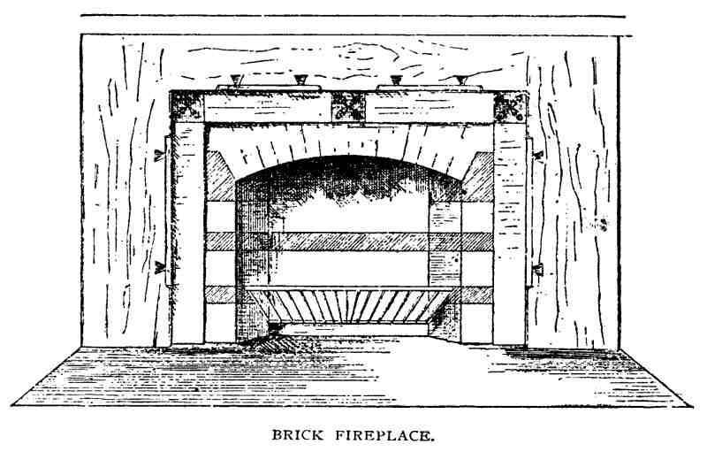
hall and in each of the rooms not commonly used, you would probably afford one or
two open fires for those constantly occupied, and keep comfortable with less outlay for
fuel than with a furnace. But you would need an accommodating fool to make your fires,
and an industrious philosopher to keep them burning. In this matter of warming and
ventilating the more you know the more you will wish to learn. My hope is to set you
thinking and studying. Read Dr. George Derby's little book on Anthracite and Health,
from which I have drawn already for your benefit; read the statistics of the increase of
pulmonary diseases; get the physiological importance of fresh air so clearly before your
mind's eye that your dinner seems a secondary consideration, and don't be deceived by
any bigoted commentators, or forget to use your own common-sense.
While warming our backs we may dispose of some adjacent matters. You can make a
very pretty fireplace for wood of the common buff-colored fire-bricks, either alone or
variegated with good common red bricks; a hearth of encaustic tile, pressed bricks, or
even Portland cement. Let the hearth be a generous one, two and a half feet wide, and at
least two feet longer than the width of the fireplace, if you mean it for actual use. You
must not suppose I object to cheap things because they are cheap and therefore common.
The more so the better if they have real merit; but the marbleized slate mantels so
abundant have not enough intrinsic beauty to justify them in supplanting the more honest
and unpretending ones of wood. Real marble ought to be too expensive for such houses as
yours.

With a furnace your house becomes a lumber-kiln, and any wood that has not been
tried as by fire will, under its influence, warp and crack and shrink; in carpenters' phrase,
"it tears the finish all to pieces." The rapid shrinking of the joists and studs near the hot-
air pipes is also apt to cause cracks in the plastering that would never appear if the whole
frame could shrink evenly, for shrink it will more or less. The application of these
remarks would be, putting in the furnace as soon as possible, and keeping it steadily at
work drying sap from the wood and water from the plastering till it enters upon its
legitimate mission of warming the house.
When you have read all this about heating and ventilating two or three times over,
these conclusions will begin to crystallize in your mind:—
Open fires give the surest ventilation and the best cheer.
If stoves are used for economy, fresh air must be systematically admitted.
Furnaces are immensely useful to warm the bones of the house and as a sort of reserve
force; but the heat they give is somewhat like a succession of January thaws.
If you begin to investigate you will discover a fearful amount of ignorance and
indifference where you should find positive information, and the most discouraging
obscurity or conflicting statements among those who profess to be wise in such matters.

LETTER XLI.
From John.
ETERNAL VIGILANCE.

MY DEAR ARCHITECT: You did well to send the key to your puzzles, else I might
have frozen to death before finding out how to keep warm. But you've earned your

discharge, which I forward herewith. Now I'm going to send you some grains of
wisdom, gathered during my experience in building, which you may distribute at your
discretion among your clients. When a man—I don't care if it's Solomon himself—
undertakes to build a house, tell him from me, to wind up all other earthly affairs before
beginning; wind them up so tight they'll run for a year or two without any of his help.
Then turn over a new leaf,—learn to get through breakfast before seven A.M., in order to
be on the ground every moment, from the time the first spadeful of dirt is thrown out till
the last touch of paint is put on. You may make full-sized drawings for him of every stick
and stone, write specifications by the yard, and draw up a contract that half a dozen
lawyers can't expound, there'll still be a thousand little things that won't be done as he
wants them.
The openings in the basement wall somehow get out of place, an inch or two too high
or too low, or at one side, then the windows over them will look askew. The air-spaces in
the wall will be filled up where they ought not to be, or left out where they ought to be
filled; then the frost will go through one and the rats the other. If he uses colored mortar,
it will be too dark or too light, or too something,—then he'll be obliged to paint the whole
wall. The drains won't be put in the right place, or they'll pitch the wrong way; then he'll
have to dig out new ones. The receivers for the stove-pipes will be forgotten or set in the
ventilating-flues; then he might as well have no chimney. The masons will drop bricks
and mortar and trowels down the flues; then he'll have to climb upon the roof with a brick
tied to a rope and try to churn them out. Just at the place where the flues ought to be
plastered outside and in, against the floor and roof timbers, the masons can't reach, and
like as not they'll turn a brick up edgewise if a joist happens to crowd; then his house will
burn up and never give him any more trouble.
The war with the masons is short and sharp; that with the carpenters long and tedious.
There are ten thousand ways you don't want a thing done, only one that suits you. Setting
partitions looks like easy work; I don't believe a house was ever built in which all of them
and the doors through them were in just the right places. I know they 're not in mine. I'd
give three times the cost of the door if one of them could be moved, two inches, and as
much more if another could be made six inches wider. I tried to have one of the mantels
set in the middle of one side of the room, but somehow it got fixed just enough away
from the centre to look everlastingly awkward.
The rough work gets covered up pretty quickly, but it pays to keep watch and see that
the spikes are put in where they belong; that the back plastering reaches quite up to the
plate and down to the sill; that timbers are not left without visible means of support, or

hung by "toe-nails" when they ought to be well framed and pinned. It's hard to make a
carpenter believe that plastering cracks because his joists and furrings and studs won't
hang together, but it's true a good many times. You like, also, to have something more
than a good man's assurance, that the furnace pipes are "all right," and will sleep better on
windy nights if you have seen all exposed corners guarded by a double lining.
The gas-man had his work to do over because some of the drop-lights were not in the
centre of the ceilings.
I tremble to think of what might have been if I had left the painter to his own devices.
It seems very clear to say you'll have the outside painted a sort of a kind of subdued gray,
with trimmings a little darker, bordering on a brown; but unless you stand over the paint-
tub with a loaded revolver, you'll get anything but what you expect. It may be a great deal
better, but it won't be what you wanted. By the way, there's a great responsibility resting
on the painters,—I don't mean the old masters, nor the young ones either, who seem to
have forgotten that outside decoration was once considered quite worthy the tallest
genius,—but the more modest artisans, who call themselves house and sign painters.
Their broad brush often makes the beauty or the ugliness of a whole village. I'm ready for
any suggestions on the subject. Hanging the doors is another point that needs watching.
They'll be sure to open the wrong way. I've had three changed already, and I'll never hang
another door with less than three butts, whatever its size. I suppose they always settle
more or less. Why don't the workmen make allowance for it in fixing the catches? I
tremble when I think of the painters, but I rejoice at my watchfulness when I reflect on
the plumbing. The chances for leaking and freezing and bursting; the hidden pipes and
secret crooks that were possible and only avoided by constant oversight! Now I can put
my hand on every foot of pipe in the house, know where it goes to, what it's for, and that
it won't burst or spring a leak with fair usage. I don't call it just the thing to drive a
tenpenny nail square through a lead pipe, pull it out, and say nothing about it. You want
to be on hand, too, when the trimmings are put on, and see that they are not too high or
low, or fixed so you will bruise your knuckles every time you pull out the drawers or
open the cupboard doors. Speaking of cupboards, there's no end to the bother if you don't
just camp down in the pantry and stay there till the top shelf is up and the bottom drawer
slides in its groove. In spite of our efforts, Mrs. John says there's no place for her tallest
covered dish except the top shelf, which she can't reach without a step-ladder. You'll
never know whether you are specially bright or the joiners extra stupid, but it's certain
your way won't be their way, whichever is right. I say the man who pays his money
should take his choice. But I haven't time to tell the whole story. It's the same thing from
first to last. The only sure way of having a thing done well is to do it yourself; the next

best is to tell some one else precisely how to do it and then watch them till it's done.
The worst of these little blunders is, that they won't improve with age. They stare at you
every time you see them, and they'll rise up before your great-great-grandchildren,
monuments of your carelessness and ignorance.
I told you my house was half done when it was well begun; now that it is almost done
it seems to me only fairly begun.
Yours,
JOHN.

LETTER XLII.
From the Architect.
SAVED BY CONSCIENCE.

Dear John: We are just beginning to learn the importance of color. I don't allude to the
wonderful revelations of the spectroscope almost passing belief, but the new departure in
the useful art of house-painting.
The old weather-stained, unpainted walls were not unpleasant to see; even the
unmitigated red, that sometimes made a bright spot in the landscape, like a single scarlet
geranium in the midst of a lawn, had a kind of amiable warmth, not to be despised; but
there is no accounting for the deluge of white houses and green blinds that prevailed a
few years ago. If nature had neglected our education in this respect we might be excused
for our want of invention.
With infinitely varied and ever-changing colors smiling upon us at all times and in all
places, it is blind wilfulness not to see and strive to imitate them. We need not look to the
sky nor even to the woods in their summer brightness or autumn glory. The very ground

we tread glows and gleams with the richest, softest tints of every hue and shade. Look
through a hole in a piece of white paper and try to match on the margin the color you find.
Turn in a dozen different directions, avoid the trees and the sky, and you will have, in
summer or winter, a dozen different colors. Look in the same places to-morrow, and they
will all be changed, an endless variety. Some one of these soft and neutral tints should
clothe the body of your house. Enliven it, if you choose, with dashes of crimson, green, or
even blue and gold, but use these bright colors carefully. Aim to make your house (in this
as in all other respects) in harmony with its surroundings, not defiant of them. Your
proffered advice shall be duly applied, for it's true that a man may easily occupy all his
leisure time, be it more or less, in watching the building of his home, however carefully
the work may be laid out before he begins. No two builders will interpret and execute the
same set of plans exactly alike.
There are different habits of training and tricks of trade. What seems finished elegance
to one is coarse awkwardness to another; and when you enter upon the more artistic part
of the work, there are fine shadings impossible, even with the best intent, to any save the
cultured hand and eye. The inability to perceive and therefore to bring out these delicate
expressions in the execution of the work must be borne patiently. We can pardon failure
when it follows an humble, honest effort.
The unpardonable sin of builders is their wilful attempt to improve the architect's
design by making alterations in cold blood, through sheer ignorance and conceit. They
will reduce the size of the doors and windows; substitute some other moulding for that on
the drawing; or tell you they have made a bracket, or a bay-window, or a cupola, for Mr.
Rusticus that looked first-rate, and advise you to have the same thing. No thought of
harmony or fitness, no fine sense of a distinctive idea, pervading the whole, and giving it
unity and character, ever enters their heads. Argument and persuasion are alike useless.
Your only safety lies in finding some young builder, who is not yet incurably wise in his
own conceit, or an old one, who has learned that, while architects are not infallible, the
taste and opinions of a man who studies faithfully a special department, are entitled to
more respect than even his own. As you say, these defects are commonly incurable.
Neither is there any redress. The builders will either tell you they "couldn't help it," "did
the best they knew how," "thought the lumber was seasoned," "understood the plans that
way," or else insist that it's better so,—and maybe ask you to pay extra for what you do
not like. As to your own right to spoil the house by any alterations that strike your fancy
or accommodate your purse, that is unquestioned. Architects who insist upon your having
what you don't want or choose to pay for, exceed their prerogatives, and bring disfavor
upon us considerate fellows.
We
never try to dissuade a man from carrying out his own

ideas. We only beg him to be certain that he has a realizing sense of what he is
undertaking, then help him to execute it as well as we can. The more he leaves to our
discretion the more hopefully do we work.
All this is too late for you, but you may pass it along to Fred, the schoolmaster, Miss
Jane, and any other friends or neighbors who may be in an inquiring mood. Tell them,
too, there is no safety, even with the utmost vigilance, unless every workman carries with
him that old-fashioned instrument, a conscience. Give me credit here for great self-
control. This is the place for some preaching of the most powerful kind, but I refrain,
knowing you are too much engrossed with the finishing of your house to heed it. Do you
remember how it is recorded in terse Scripture phrase that "Solomon builded a house and
finished it"? Evidently the finishing was then quite as important and onerous a matter as
the building. I think it is a great deal more so. The carpenters and masons, to whom you
pay a certain sum of money, build it. Before they come and after they go you exercise
upon it your noblest, manliest faculties. Yet it will never be done. The walls may not
grow any larger or the roof any higher, but every year will add some new charm, some
new grace and harmony without and within. More and more the ground around it, the
trees, the walks, and the grateful soil will assimilate themselves to its spirit. More and
more each article of furniture will grow to be an essential part of the home, dear for its
comfort, and beautiful in its fitness and simplicity. More and more you will learn the
worthlessness of boastful fashion, and the exceeding loveliness of truth.

LETTER XLIII.
From John.
FINAL AND PERSONAL.

MY DEAR ARCHITECT: We've moved in. The house wasn't done but the plastering
was dry, and the paint too, what there is of it, and enough rooms were finished to hold us

comfortably. Mrs. John thought we should somehow feel better acquainted if we took
possession while things were in a chaotic state, before the house had a chance to put on
airs, and make us feel like intruders; that it would fit us better if it wasn't entirely
hardened before we crawled into it. I told her 't would be a great deal easier to wait till
everything was cleared up and we could take a fresh start, but she couldn't see it in that
light. Said she'd known lots of folks to be completely overpowered by a new house, and
she proposed to take it while it was sort of helpless, and would be under obligation to her.
It's better, too, according to her notions, to get familiar with the rooms before furnishing
them, and—I've forgotten what other reasons, all good enough but not exactly correct, as
I've since found out. I'd noticed some unusual and rather suggestive performances of late,
but wasn't quite prepared for a request to rent the old house the very day we moved.
Matters seemed to culminate one night after the schoolmaster had received your sketches
and estimates for his brick beginnings. I can't say as to their merits architecturally, but
they cleared one of the rough places in a certain course that never runs quite smooth. The
dining-room and kitchen arrangements are all right, and the establishment is already
begun. It will take all summer to finish it, and, meantime, Sister Jane will have an
opportunity to reduce some of her fine theories to practice in our old cottage. Whether
they will all stand the test remains to be seen. I only hope these two wise people won't pin
their sole chance of domestic happiness to scientific housekeeping, and if common-sense
and dutiful intentions fail, as they sometimes will, that love will come to the rescue. Fred
will build next year. He 's concluded it's better to have his work well done than done too
quickly.
Yours,
JOHN.

BY WAY OF APPENDIX.
A CHAPTER FROM ACTUAL EXPERIENCE.

Now you can stay just as long as you please, and I wouldn't have you feel hurried, on
any account; but if you're really going to go pretty soon, I'd like to know when it's to be,
so I can lay my plans accordingly."
Thus our good landlady, when we said our new house was beginning to look nearly
ready for us. A most reasonable request, and we, always cheerfully responsive to such,
replied, "By all means; certainly; quite right: we'll see the workmen to-day and find out
just when the new domicile will be ready for us."
In pursuance of this object, straightway then we flew to the carpenter. "Tell us, O
worthy master!" we cried, "when shall the new house be done?"
"Wal, let me see." And he scratched his head with the scratch-awl. "It's a'most done
now. Ther ain't much more to do. We've pretty much finished up. Ther's the doors to hang
and trim, 'n' the closet shelves 'n' things to fix up; the stairs ain't quite done, n'r the front
steps. I d'nno; ther's a number o'little jobs 'round,—don't amount to much,—coal-bin,
thresholds, and one or two things you want to change; take three or four days, I guess, if
the plumbers and furnace folks get out of the way; week, mebbe."
"You think, then, by a week from next Saturday—to-day is Thursday morning—you
will have everything cleared up?"
"O yes, easy!"
Alas! ingratitude is not confined to republics. We thought it a most kind and judicious
thing to grant nine days, when but three or four—six at the most—had been asked.
Worldly wisdom would have said, "No, sir; three days you can't have; it must all be done
to-morrow night." But we are not worldly-wise; innocent, confiding, and rejoicing, we
went our way,—went our way to the plumber.
"O good plumber!" quoth we, "how long will it take you to complete the work you
have begun so well?"
"How long? 'Twon't take no time. Just as soon as the copper comes for the tank, I shall
finish it all up. There ain't much of it, anyhow; it's all done but that."
"And when is the aforesaid copper coming?"
"When is't a coming? Any time. Shouldn't be surprised if 'twas here now."

"You can finish it then surely within a week."
"Within a week? I sh'd think likely,"—the last remark backed up by such a smile as
made further question impossible.
Once more we pursued our investigating tour, saying to the prompt proprietor of the
centrifugal-stove store, "Is that new furnace that is to make June of January, that never
does what it ought not to do or leaves undone what ought to be done, that asks a mere
handful of coal every twenty-four hours and runs itself, ready for its trial trip?"
"It is, sir."
"Registers all set and—"
"Well, no; the registers can't be set till everything else is out of the way."
"Ah, yes, of course; but 't won't take long to do that?"
"They shall all be set in the twinkling of an eye, at a moment's notice."
And now it only remained to hie away to the painter. So we hied and hailed him.
"Tell us, O man of many hues! how much time will you need to paint and stain and
grizzle and grain and tint and stripe and fill and shellac and oil and rub and scrub and cut
and draw and putty and sand-paper and size and distemper and border and otherwise exalt
and glorify the walls and woodwork of our house, after the other workmen are through,
making allowance for what you have already done and will be able to do while they are
still at work?"
"I tell you what it is, Mr. Architect, it shall be done just as soon as possible. The fact
is, we've got the heft of it done now. We shall follow the carpenters up sharp, and get
through almost as soon as they do."
Outwardly serene, but smiling triumphantly within, we went to our daily roast-beef,
and in the sweet simplicity of a blissful ignorance and a clear conscience assured our
patient hostess that the dog-days and her unworthy guests should go out together. Yet we
never told a lie or wilfully deceived any man, much less a woman.
But we anticipate. At the close of the third day we essayed to examine progress at the
new house. As we approached, a dim and doubtful but wondrous pleasant anticipation
took possession of our fancy. What if it should, indeed, be finished! The carpenter had

suggested three or four days,—three had already passed. The painter was to get
through
almost
as soon, the plumber would surely be out of the way, and there would be
only the furnace registers. It was, perhaps, too good to be true, and we lingered to give the
notion time to grow. Opening the door at last, we received something the same shock the
traveller feels when he encounters a guide-post telling him the next town is half a mile
farther on than it was three miles back. But we've not lived forty years without learning to
bury our "might-have-beens" with outward composure, whatever the internal commotion.
We remembered there was still a week, and resolved to keep a sharp lookout that no time
was wasted; an idle resolution, for the workmen were as anxious to get through as we
were to have them. Faithful industry and attention we may demand, haste we have no
right to ask. But our men actually hurried. We were instant in season and out of season,
and can testify, with both hands in our empty pockets, that there was not an hour wasted.
Yet our full-blown hopes fell, as the roses fall, leaf by leaf; drop by drop our patience
ebbed, till, ere the close of the week, we sank slowly down on a pile of black-walnut
shavings in the calmness of despair.
To make a long story short, we gave up, beaten, trespassed a week on our long-
suffering hostess, then went to visit our rich relations. They were glad to see us when we
came, and wondered how long we were going to stay. We thought best to let them
wonder, which they did for the space of a few weeks, when we folded our nightgowns
and silently stole—not the spoons, but ourselves—away.
We mentioned the calmness of despair. From that depth it is often but a single step to
the serenity of faith, on which sublime height not the wreck of matter and the crush of
worlds hath power to vex or make afraid, much less a few pine shavings and the want of a
little paint. Despair is never endless; it's a short-lived emotion at the worst, a selfish one
at the best. Moralizing thus, it was by some means revealed to us that people are happy in
paying twenty-five dollars a week at Martha's Vineyard and Mount Desert for the blessed
privilege of living in unfinished and unfurnished rooms,—breathing plenty of fresh air,
typhoid malaria thrown in,—and eating such food as the uncertain winds and waves may
waft thither. If at Mount Desert why not at Rock Rimmon, especially as the cost is
somewhat less, the fresh air equally abundant, with nothing more malarious than the
pungent perfume of the pines, and all the products of the civilized world within easy
reach? Moreover, our third, fourth, and fifth stories—the floor of the latter just above the
ridge pole, its ceiling just beyond the stars—were, for all purposes of use and comfort,
ready for occupation. So we entered, hung up our hats, and told the busy builders we had
come to stay.

Which we have done; and now it's the first of October. The leaves are falling, the
rooks are calling, the crickets are crawling, and the katydids are—well, squalling. There's
a work-bench bigger than Noah's ark in the drawing-room, another in the library, next
size larger, five tool-chests in as many different rooms, a thousand feet of lumber in the
front hall, and nine hundred and thirty-seven different colored paint-pots in the guest-
room,—more or less. We pry into cupboards and drawers with our finger-nails, we keep
next the wall going up stairs, draw water through a straw, and to open doors we thrust a
square stick through a round hole and twist and turn till the stick breaks or the door opens.
Generally the stick breaks.
But we are no longer desperate. The sound of the builder's axe and hammer mingles
harmoniously with the rattling of dishes and the drumming of the piano. A profound
peace possesses our souls, for Nature's own infinite glory is around us, and we go from
our castle in Spain to our cottage by the sea, from our house of active industry to our
restful home in the New Jerusalem, with the opening and the closing of a door. We are
not anxious or impatient, being well assured that steadfast industry will finally conquer
and our house be finished as far as mortal house should be. Which leads us to remark just
here, that a man ought never to think his house is quite complete; he will not, if he is
wise, and grows as long as he lives. Our present point is the inevitable delay in the
outward finishing to which home building is especially subject,—a difficulty familiar to
all who have tried it, but which people cannot always get out of by jumping squarely into
it as we have done.
There are various reasons for it. A superficial view of building is one. The masons are
scarcely noticed before the foundation-walls are laid; the walls shoot up in a single day;
the roof spreads its saving shelter as easily as though it were a huge umbrella; the
windows open their eyes in new-born wonder; the chimneys breathe the blue breath of
home life out into the world; the painter touches the clapboards with his magic wand; and,
with one accord, all men cry out, and especially all women, "Wal, I do declare! That air
house goes up in a hurry, don't it? Guess there hain't much but green lumber gone into
that. Folks'll be movin' in 'n a few days. Ketch me goin' into a house like that! I'd a good
deal druther live in an old house than die in a new one."
But, for some reason, the folks don't move in. Week after week passes without visible
change till we hear no more of haste, but owner and neighbors grow impatient, and can't
for their lives see why that house wa'n't done weeks and weeks ago! In point of fact, when
it appeared almost wholly built, it was hardly begun. The work thus far had been of the
sort that can be quickly executed, much of it done by machinery. Even after the plastering
is dry, the floors laid, the windows in, and perhaps the greater part of the interior
woodwork in place, the actual labor of finishing is but fairly begun.
Changes always cause delay more or less serious. Whoever makes alterations in his
house builds four houses. There is the first doing it, which is one; then there is the
"cussing and discussing," the hesitating and final deciding to make the change,
equivalent, at least in time and nervous wear and tear, to the original work, which is two;
the undoing is three; and the final adjusting it to your mind is four. Woe to him by whom
the change cometh, but come it will. It can be wholly avoided only by having things done
as you do not want them and will never be satisfied to leave them. Of course, the want of
plans is a fruitful source of alterations. We are too modest and too sensible to say all plans
should be drawn by an architect, but carefully prepared they must be, and, what is
commonly more difficult, thoroughly understood by the party most interested, that is, the
owner.
Another reason why the lengthened sweetness of finishing is so long drawn out comes
from the constant increase of "modern improvements,"—accessories deemed essential to
the completeness of home comfort and convenience. Nowhere is the fertility of inventive
genius more apparent than in these household appliances, to all of which the apostolic
injunction applies, "Prove and hold fast the good." Hold fast and be grateful, for they are
the world's best benefactors whose work makes happier homes.

THE END.

